­



XR Flight Operations Manual

Version 3.1

*Publication Date: 14-Aug-2021*

Vessel Versions: **XR5** 2.0 / **XR1** 2.0 / **XR2** 2.0

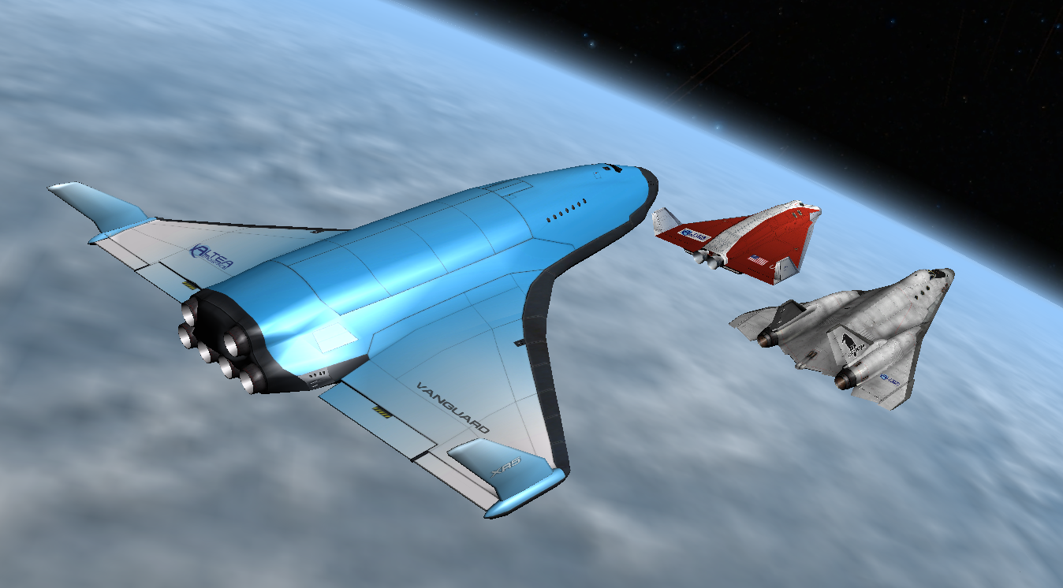

Copyright 2006-2021 Douglas Beachy.

Licensed under the [GNU General Public License](https://www.gnu.org/licenses/).

Web: [https://www.alteaaerospace.com](https://www.alteaaerospace.com/index-4.html)

Email: <mailto:doug.beachy@outlook.com>

Orbiter Forum: [dbeachy1](http://www.orbiter-forum.com/member.php?u=104) ([https://orbiter-forum.com](https://orbiter-forum.com/forumdisplay.php?f=51))

Table of Contents

DG-XR1 Development Team 3

XR5 Vanguard Development Team 3

XR2 Ravenstar Development Team 3

Voice Actress (all vessels) 4

DG-XR1 Beta Testers 4

XR5 Vanguard Beta Testers 4

XR2 Ravenstar Beta Testers 4

XR Flight Operations Manual Translations 5

Acknowledgements 5

License & Copyright 6

Dependencies 6

Summary 7

Features 7

Requirements 12

Installation 12

Configuring Your XR Vessel 17

Cheat Codes 21

Flying your XR Vessel 21

Structural and Thermal Limits 25

Custom Shortcut Keys 26

XR Vessel Custom Shortcut Keys 27

XR Attitude Hold Shortcut Keys 28

XR Descent Hold Shortcut Keys 28

XR Airspeed Hold Shortcut Keys 29

Center-of-Gravity Shifting 29

Using the Multi-Display-Area (MDA) 30

Walkthrough: Launch from KSC to Low-Earth-Orbit 31

Fuel and Oxygen Consumables Management 37

Replenishing Fuel and LOX Tanks 37

XR2/XR5 Only: Using Payload Bay Fuel/LOX Tanks 39

Coolant Temperature Management 40

APU Fuel Management 42

M.E.T. and Interval Timers 43

Damage and Warning Display 44

Attitude Hold Autopilot 46

Reentry Walkthrough 47

Descent Hold Autopilot (Hovering and Landing) 50

Airspeed Hold Autopilot 52

Using the Docking Camera (XR5 Only) 54

Payload Management (XR2/XR5 Only) 55

UCGO Support 56

Grappling Payloads 57

Deploying Payloads 59

Using the Payload Editor 62

Creating Your Own Payload Module 64

Publishing Your Payload Module 67

XR2-01_Bay/XR5-01_Bay Vessel Saved in Scenario Files 67

Installing and Using a Custom Skin 68

Submitting a Feature Request or Bug Report 68

Appendix A: Notes 69

Appendix B: Technical Data 70



*The Future Is Now.*

# DG-XR1 Development Team

|  |  |
| --- | --- |
| Douglas Beachy | Systems design, C++ code, 2D graphics, dialogs, exterior textures, documentation |
| Don Gallagher | 3D mesh tweaks, hover doors, SCRAM doors |

# XR5 Vanguard Development Team

|  |  |
| --- | --- |
| Douglas Beachy | Concept, systems design, C++ code, 2D graphics, dialogs, documentation |
| Russell Hicks | 3D modeling, internal cockpit textures, model design, cargo module models, some animation code |
| [PennyBlack](http://orbiter-forum.com/member.php?u=4637) | Ship textures |
| [Carmen A](http://orbiter-forum.com/member.php?u=5893) | Fuel, LOX, & H20 cargo modules |
| Tom Fisher | AIA cargo module |

# XR2 Ravenstar Development Team

|  |  |
| --- | --- |
| Douglas Beachy | Systems Design, C++ code, 2D graphics, dialogs, documentation. |
| Steve “Coolhand” Tyler | Concept, model design, 3D modeling, textures, cargo module models, Lee and Kara astronaut models, XR2 turbopack models, custom main/hover/RCS/SCRAM sound effects. |

# Voice Actress (all vessels)

* Sally Beaumont (<https://www.sallybeaumont.com/>)

# DG-XR1 Beta Testers

* Cale Nicholson (Cale)
* Chris Mueller (BuckTheInfernal)
* Christopher Turner (CHRISTU)
* Don Gallagher (Donamy)
* David A. Seiver (BigDAS)
* Franconis Wisard (Zebuwin)
* Jim Ladmo (Delboy)
* Jógvan Trondesen (C3PO)
* Luca Rizzardi (rigel489)
* Matt Picio (Matt P.)
* Michael Sturm (Sturmn8r)
* Michael Weatherton (TWIFOSP)
* Mohd Ali (computerex)
* Patrice Fort (Fort)
* Steve Symonds (Scorpius)
* Zachary Grillo (Jgrillo2002)
* Zachstar Brown (Zachstar)

# XR5 Vanguard Beta Testers

* Callum Massey (kais58)
* Charles Singh
* Don Gallagher (Donamy)
* Jógvan Trondesen (C3PO)
* John Mark Simpson (Duke)
* Julian Soulages (jsoulages)
* Michael Scott (Zaphod)
* Neil Forrester (scarecrow)
* Randy Stearns (yagni01)
* Russell Hicks (Russ_H)
* Stefan Sondermann (gnome_gemini)
* Tom Fisher (wehaveaproblem)

# XR2 Ravenstar Beta Testers

* Ben Stickan (TSPenguin)
* Blair Hoddinott (orwellkid)
* Cale Nicholson (Cale)
* Charles Singh
* Dennis Reynolds (karpador)
* Jógvan Trondesen (C3PO)
* John Mark Simpson (Duke)
* Randy Stearns (yagni01)
* Ryan Kingsbury (Countdown84)
* Stefan Sondermann (gnome_gemini)
* Tristan Lostroh (TL8)
* Zachary Grillo (jgrillo2002)

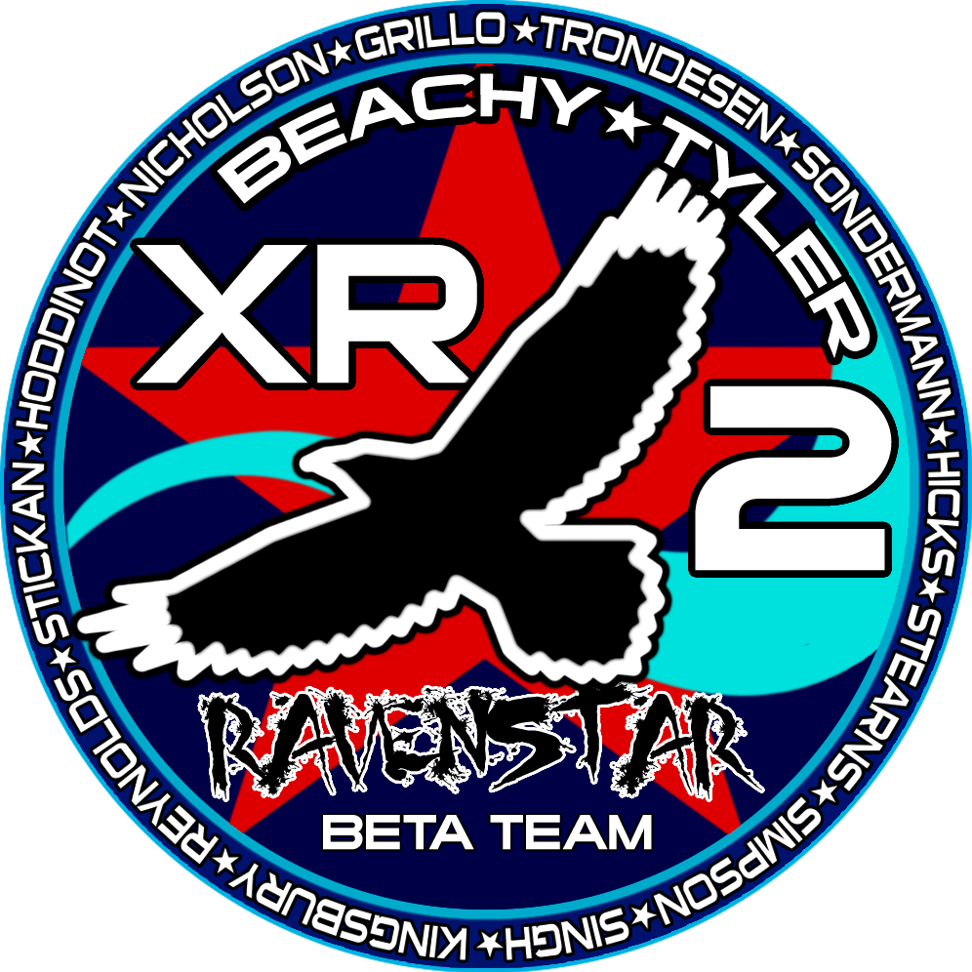

# XR Flight Operations Manual Translations

* *German*: Stefan Sondermann (earlier XR5 manual)
* *Spanish*: Julian Soulages (earlier XR5 manual)
* *Italian*: Ugo Palazzo (XR Flight Operations Manual Version 2.4)

# Acknowledgements

Many thanks to [Dr. Martin Schweiger](http://www0.cs.ucl.ac.uk/staff/M.Schweiger/) for his outstanding [Orbiter](http://orbit.medphys.ucl.ac.uk/orbit.html) program, which he released as open-source under the MIT license in August 2021.

Special thanks to [Don Gallagher](http://www.orbiter-forum.com/member.php?u=15) for his early XR5 Vanguard prototype meshes that helped me figure out how I wanted the Vanguard to look.

Thanks to [Greg Burch](http://www.gregburch.net/) for kindly granting me permission to use his high-polygon astronaut meshes.

Thanks to [Frying Tiger](http://www.orbiter-forum.com/member.php?u=471) on the Orbiter Forum for developing the original DeltaGlider-S mesh and virtual cockpit for Orbiter upon which the XR1 is based.

Special thanks to Stefan Sondermann, Julian Soulages, and Ugo Palazzo for translating the XR Flight Operations Manual into German, Spanish, and Italian, respectively. See my [Web site](http://www.alteaaerospace.com/) for more information.

# License & Copyright

This software copyright © 2006-2021 Douglas Beachy.

This program is free software: you can redistribute it and/or modify it under the terms of the [GNU General Public License](https://www.gnu.org/licenses/) as published by the Free Software Foundation, either version 3 of the License, or any later version.

This program is distributed in the hope that it will be useful, but WITHOUT ANY WARRANTY; without even the implied warranty of MERCHANTABILITY or FITNESS FOR A PARTICULAR PURPOSE. See the GNU General Public License for more details.

You should have received a copy of the GNU General Public License along with this program. If not, see <https://www.gnu.org/licenses/>.

Email: mailto:doug.beachy@outlook.com

Web: [https://www.alteaaerospace.com](https://www.alteaaerospace.com/)

## Dependencies

1) Portions of the XR vessel source code, mesh, and textures are based on and/or use modified portions of the original DeltaGlider sample vessel code and assets, which are now licensed under the MIT license (<https://opensource.org/licenses/MIT>). Orbiter's license as of 14-Aug-2021 is quoted below:

Orbiter Space Flight Simulator

MIT License

Copyright 2000-2021 Martin Schweiger

Permission is hereby granted, free of charge, to any person obtaining a copy of this software and associated documentation files (the "Software"), to deal in the Software without restriction, including without limitation the rights to use, copy, modify, merge, publish, distribute, sublicense, and/or sell copies of the Software, and to permit persons to whom the Software is furnished to do so, subject to the following conditions:

The above copyright notice and this permission notice shall be included in all copies or substantial portions of the Software.

THE SOFTWARE IS PROVIDED "AS IS", WITHOUT WARRANTY OF ANY KIND, EXPRESS OR IMPLIED, INCLUDING BUT NOT LIMITED TO THE WARRANTIES OF MERCHANTABILITY, FITNESS FOR A PARTICULAR PURPOSE AND NONINFRINGEMENT. IN NO EVENT SHALL THE

AUTHORS OR COPYRIGHT HOLDERS BE LIABLE FOR ANY CLAIM, DAMAGES OR OTHER LIABILITY, WHETHER IN AN ACTION OF CONTRACT, TORT OR OTHERWISE, ARISING FROM, OUT OF OR IN CONNECTION WITH THE SOFTWARE OR THE USE OR OTHER DEALINGS IN THE SOFTWARE.

----

2) The XR2's DLL loads the XR2's mesh at runtime. However, the mesh is not

necessary to build the XR vessel source, and the mesh remains freely

downloadable as part of every XR vessel release. The XR2's mesh and texture

files remain the copyright of their author, Steve Tyler (<mailto:steve3d@gmail.com>).

# Summary

*Welcome to the Future.*

The **DG-XR1**, **XR5 Vanguard**, and **XR2 Ravenstar** are cutting-edge spacecraft for Orbiter that are the products of over 60,000 lines of C++ code. All XR vessels are built on a common framework and share similar internal systems. Highlights include three (XR1), four (XR2), or five (XR5) 2D instrument panels that natively support 1280-, 1600-, and 1920-pixel-wide windows, high-performance Altea Aerospace SCRAM engines, complex damage simulation, custom sound effects via XRSound, over 250 voice callouts performed by voice actress [Sally Beaumont](http://www.sallybeaumont.com/), and highly precise autopilots. In addition, the XR2 and XR5 include a payload bay with full payload support via a custom instrument panel.

XR vessels are designed to be *pilots’ ships*, and with all the realism settings set to maximum, the ships are significantly more challenging to fly efficiently (and *safely*) than the default DeltaGlider; i.e., pilot workload is higher. However, each vessel is fully configurable via its configuration file (e.g., Config\XR5VanguardPrefs.cfg), and with all the realism settings disabled each vessel is just as forgiving to fly as the default DeltaGlider. The configuration file also features a custom *CHEATCODES* section that allows the user to directly set certain ship's values such as maximum engine thrust, fuel capacity, ship mass, etc.

## Features

If you are a veteran XR pilot, you will find most of all three ships’ systems familiar. However, the Vanguard is many times larger than the XR1/XR2 and the flight characteristics are completely different – particularly if you are carrying a heavy payload.

**All XR vessels include:**

* 2D instrument panel native support for 1280-, 1600-, and 1920-pixel-wide windows.By default, each XR vessel will automatically load the optimum panel width based on the window size in which Orbiter is running. However, to force a particular panel width to be used, set 2DPanelWidth in your ship’s configuration file (e.g., Config\XR5VanguardPrefs.cfg). Each main panel is low-profile in the center for maximum visibility.
* 281 unique sound effects and voice callouts; callouts performed by voice actress [Sally Beaumont](http://www.sallybeaumont.com/).
* Altea Aerospace SCRAM engines operable up to ~Mach 17 (XR1) or ~Mach 20 (XR2/XR5).
* Extensive refueling/resupply support via the lower instrument panel. In addition, Orbiter's automatic (and instant) refueling of the ship when touching down on a landing pad is disabled so that pilots may refuel the ship manually.
* Many instrument panel gauges, including:
  + Fuel display showing Main, RCS, and SCRAM fuel remaining.
  + Engine display showing

1) main engine efficiency (affected by atmospheric pressure),

2) main, hover, and SCRAM thrust levels, and

3) acceleration along all three axes in g’s and meters-per-second-squared.

The G scale automatically switches its range as necessary, providing accurate information for low-, moderate-, and high-G situations. This gauge shows the forces on the ship, so as the ship accelerates into orbit you can watch the Y axis Gs go down from one to zero. X = lateral (left-right), Y = vertical (up-down), Z = ship acceleration (front-back).

* Reworked TSFC ("Thrust-Specific Fuel Consumption") screen showing main engine and hover engine efficiency (affected by atmospheric pressure). Rocket engines are most efficient when operating in a vacuum.
* Dynamic Pressure and Static Pressure gauges; useful for optimizing your ascent when using the SCRAM engines.
* Slope gauge showing ascent/descent slope.
* AOA and Slip gauges.
* SCRAM Diffuser Temperature gauge which allows the pilot to monitor when the SCRAM engines reach the edge of their performance envelope.
* *Multi-Display-Area* (MDA) screen that has ten different modes, showing:
  + Mode 0: Airspeed Hold Autopilot
  + Mode 1: Descent Hold / Auto-Land Autopilot
  + Mode 2: Attitude Hold Autopilot
  + Mode 3: Temperature Display for hull and coolant
  + Mode 4: Systems Status Display #1
  + Mode 5: Systems Status Display #2
  + Mode 6: Systems Status Display #3
  + Mode 7: Systems Status Display #4
  + Mode 8: Systems Status Display #5
  + Mode 9: Reentry Systems Check
* Two configurable pop-up HUDs. The secondary HUD has five modes and is fully configurable for data, color, and transparency. The tertiary HUD shows status and warning messages and is configurable for color and transparency only.
* A new configuration file in your %ORBITER_ROOT%\config directory for each vessel named DeltaGliderXR1Prefs.cfg, XR5VanguardPrefs.cfg, or XR2RavenstarPrefs.cfg for the XR1, XR5, and XR2, respectively. This file allows you to configure many ship settings, including flight settings, disabling/enabling a given damage type, pop-up HUD colors and fields, etc. Read the detailed comments in each file for details.
* A robust parser that reads each ship’s configuration file. If some invalid data is encountered, the parser will log any errors to DeltaGliderXR1.log/XR5Vanguard.log/XR2Ravenstar.log in the main Orbiter startup directory and blink an alert message at the bottom of the screen.
* Full reentry heating and damage support. Hull temperature readouts are displayed by mode 3 on the MDA screen, and may be switched between Kelvin, Fahrenheit, and Celsius by clicking the blue block on the touch screen.
* Realistic fuzzy logic hull overheating support: the ship is not instantly destroyed when a hull surface exceeds maximum temperature; this is discussed in detail in the *Reentry* section later in this document.
* Master Warning System with an alarm tone and a warning light panel. Full support for audio warnings is also implemented.
* Highly precise and efficient *Attitude Hold* autopilot that holds a set pitch/AOA and bank while neutralizing yaw (i.e., *yaw dampening*); typically used to hold pitch and bank during reentry and to hold attitude in an atmosphere.
* In an atmosphere the *Attitude Hold* autopilot holds attitude using three methods simultaneously: 1) elevator trim, 2) a *center-of-gravity shift* feature that works by pumping fuel forward or aft, and 3) RCS jets. The combination of these three methods allows the ship to hold a stable reentry attitude even under time acceleration. It is also extremely efficient and requires very little RCS fuel. *Attitude Hold* requires APU power in order to drive the center-of-gravity pumps and elevator trim.
* Efficient *Descent Hold/Auto-Land* autopilot to hold a descent or ascent rate; engaging auto-land mode will land the ship in a hover efficiently and smoothly every time.
* Efficient *Airspeed Hold* autopilot to hold a given airspeed within 0.1 meter-per-second. Useful during atmospheric flight and when taxiing. *Airspeed Hold* may be enabled alongside (i.e., simultaneously with) any other autopilot mode.
* [CHEATCODES] support in the configuration file that allows you to directly set certain ship values such as the ship's mass, max engine thrust, fuel tank capacity, etc. See the comments in the [CHEATCODES] section in each ship’s configuration file for details.
* Full damage and crash simulation, including gear collapse based on touchdown vertical speed and ship mass.
* New sound effects including altitude callouts, Mach callouts, warning callouts, damage and failure callouts, and docking distance callouts. Docking distance callouts are synced to a NAV IDS or XPDR frequency, with the closest active IDS frequency taking precedence over any active XPDR frequency.
* DATA HUD to show custom keyboard shortcuts; activated via ALT-SPACE or via a button on the main instrument panel.
* Thruster translation/rotation and on/off controls (normally *NUMPAD-/* and *CTRL-NUMPAD-/*) are now compatible with [Joy2Key](https://joytokey.net/en/). [Joy2Key](https://joytokey.net/en/) has a bug where it cannot recognize *NUMPAD-/*, so the new **/** and **CTRL-/** keys do the same thing as their NUMPAD counterparts now. This means you can now assign translation/rotation switching to a joystick button by assigning buttons to **/** and **CTRL-/**.

* Custom sound behavior for the SCRAM engines: SCARM engine volume is based on *fuel flow* (i.e., the resulting combustion) -- *not necessarily on the throttle setting.*
* Configurable refresh rates for the secondary HUD and MDA screen; this significantly improves performance at high frame rates.
* Auxiliary Power Unit (APU) that powers the ship’s hydraulic systems; the APU must be running in order for hydraulic systems to operate. Depending on the config file setting the APU has limited fuel, so manage it carefully.
* Airlock pressurization/depressurization.
* Custom autopilots *Attitude Hold, Descent Hold,* and *Airspeed Hold* save and reload their state to/from the scenario file. This means you can save your scenario even while reentering or auto-landing, and then reload and continue without a hitch.

**XR1-Only Features**

* A fully active virtual cockpit (VC) similar to the default DeltaGlider’s VC; you may switch between cockpit modes by pressing F8.

**XR2-Only Features**

* A *static* virtual cockpit (VC); you may switch between cockpit modes by pressing F8.
* Hull heating visual effects.

**XR2/XR5-Only Features**

* Full payload support that supports any payload module (i.e., vessel) that exists in Orbiter that can fit in the payload bay. The XR5 Vanguard can carry up to 432 metric tons of payload, whereas the XR2’s recommended payload limit is 10.8 metric tons.
* Rotating wheels animation.
* A payload instrument panel to manage grappling/deploying payload.
* Support for auxiliary fuel and LOX tank payload modules attached in the payload bay. If attached, bay tanks will drain *first* in flight and fill *last* when ship is resupplied.

**XR5-Only Features**

* Nose wheel steering animation.
* Independent front/rear gear compression animation on takeoffs and landings: the gear compresses two meters as the ship touches down or lifts off. You can best see this by lifting off at Brighton Beach using the Descent Hold autopilot and watching from an external view. If you lift off at KSC and raise the nose, you can see the nose gear decompress first as the nose comes up, and the rear gear will decompress when the ship lifts off.
* A crew elevator to allow the crew to EVA while landed. Crew may EVA/ingress via either the top-mounted docking port or the crew elevator -- the active EVA port is selected via a switch on the upper panel. This also means that you can now EVA/ingress via the crew elevator even while the ship is docked to a station or another vessel. Elevator deployment requires APU power.
* A top-mounted docking port that includes a docking camera panel view.
* An *RCS Config* mode that switches between standard and docking RCS configurations: in RCS docking configuration, two things happen: 1) power to the RCS jets is reduced to 40% of normal to allow for precise control of the ship while docking, and 2) the control axes for the RCS jets are switched so that when you are looking along the docking port centerline camera you can use the RCS Rotation and Translation keys just as though you were looking along the nose with a nosecone docking port; i.e., it will feel "normal." For example, pressing NUMPAD-6 in translation mode will move the ship forward along the Z axis in *normal* RCS mode, but it will move the ship up along the Y axis in *docking* RCS mode. The hotkey to toggle RCS normal/docking mode is ALT-J.

# Requirements

* Windows Vista or newer.
* [Orbiter 2016](http://orbit.medphys.ucl.ac.uk/) or newer. Older Orbiter releases are not compatible with this release of the XR fleet.
* *Optional, but recommended*: XRSound. You can always find the latest version of XRSound on my [[[Web Page](http://www.alteaaerospace.com)](http://www.alteaaerospace.com)](http://www.dougsorbiterpage.com). Although you may fly XR vessels without XRSound installed, XRSound is highly recommended.
* *Optional:* XR Vesselssupport pluggable custom third-party skins; refer to my [[[Web Page](http://www.alteaaerospace.com)](http://www.alteaaerospace.com)](http://www.dougsorbiterpage.com) for list of custom skins available for each ship.

# Installation

This section details how to install and configure you XR vessel. Note that each XR vessel is an *Orbiter add-on* and requires that Orbiter be installed first.

1. Install [Orbiter 2016](http://orbit.medphys.ucl.ac.uk/) or newer. Older versions of Orbiter are NOT SUPPORTED by this release of the XR fleet.
2. *Optional, but highly recommended:* Install XRSound if not already installed. You may always find the latest version of XRSound on my [[[Web Page](http://www.alteaaerospace.com/index-3.html)](http://www.alteaaerospace.com)](http://www.dougsorbiterpage.com).
3. *Optional but highly recommended:* Install the DirectX 9 (D3D9) Orbiter Graphics Client. Orbiter’s framerate is much higher using DirectX 9 than it is using the default DirectX 7 client included with the Orbiter core. A link to the latest DirectX 9 Orbiter Client version can be found on my [[[Web Page](http://www.alteaaerospace.com/index-3.html)](http://www.alteaaerospace.com)](http://www.dougsorbiterpage.com). *Note: don’t forget that you need to execute Orbiter_ng.exe instead of the normal Orbiter.exe in order to run the DirectX 9 Orbiter Graphics Client. You will then need to enable the D3D9Client Graphics engine in the* Modules *tab of the Orbiter launch pad.*
4. If you are upgrading from a previous version of your XR vessel, be sure to back up your vessel’s configuration file (e.g., C:\Orbiter\config\XR5VanguardPrefs.cfg) file if you customized it. Do not simply copy your original configuration file over the new one installed by the XR vessel’s zip file; the new configuration file contains new settings not present in older configuration file versions.
5. Unzip the XR vessel’s distribution file into your Orbiter folder; e.g., C:\Orbiter.
6. If you are upgrading a previous version of your XR vessel, merge your settings back into the new configuration file using your favorite text editor.
7. Bring up Orbiter to display the Orbiter Launchpad. *Note: if you installed the DirectX 9 graphics client as is recommended, execute Orbiter_ng.exe instead of Orbiter.exe: Orbiter.exe always runs with its built-in DirectX 7 graphics engine.*
8. Click the *Modules* button.
9. Click the checkbox next to *XRSound* in the *Sound module for Orbiter* section to activate the module. *Note: if you installed the DirectX 9 graphics client as was recommended, activate the D3D9Client module as well.*
10. Click the *Video* button and set the screen resolution to your taste. **NOTE:** remember that XR vessels support 1280-, 1600-, and 1920-pixel-wide 2D panels. If your display supports it, a width of 1920 pixels is recommended; e.g., 1920x1200, 1920x1080, etc. Note that the screen *height* in pixels is not critical since the panels are only about 640 pixels high. If you are running in a window, a resolution of 1926x1200, 1606x1200 or 1286x1024 is recommended to allow room for the borders, although window *height* is not critical. XR Vessels will automatically load the optimum-width panel based on your video settings. If you want to use force a particular panel resolution instead, edit your configuration file and set 2DPanelWidth.

It is also recommended that you click the "Disable Vertical Sync" checkbox so your framerate can run at full speed: the higher the framerate, the more accurate the simulation is. If the scanline tearing that can occur with vsync disabled bothers you, enable vertical sync again by unchecking *Disable Vertical Sync*. Note, however, that limiting the framerate will also reduce the accuracy of the simulation.

In addition, ensure that *Color Depth (bpp)* is set to 32 instead of 16: running in 16-bit color mode may produce odd colors on the screen and is not recommended.

1. You can adjust the *Panel Scale* value in the *Parameters* tab as necessary to stretch the instrument panels, although panels usually look best if they are not stretched (i.e., panel scale 1.0). An *MFD refresh* value of something below 0.5 is recommended; 0.1 is a good place to start. If you see a noticeable framerate hit with 0.1, try upping the value slightly.
2. If you have a joystick, go into the *Joystick* tab and configure it. Be sure to also run [Joy2Key](https://joytokey.net/en/) if you have it installed. (Remember that you can now configure [Joy2Key](https://joytokey.net/en/) for **/** and **CTRL-/** for RCS mode changes.)
3. Review and edit your XR vessel’s configuration file (e.g., C:\Orbiter\config\XR5VanguardPrefs.cfg, DeltaGliderXR1Prefs.cgf, or XR2RavenstarPrefs.cfg) and configure the settings to your liking. The file is fully commented, and each XR vessel allows extensive configuration of its settings. Refer to the section titled *Configuring Your XR Vessel* for details.

Now boot up Orbiter and load one of the XR scenarios installed under the C:\Orbiter\Scenarios folder (e.g., Scenarios\XR2 Ravenstar).

Refer to later sections in this manual for details on how to fly your XR vessel. Welcome aboard!

The screenshots below compare the Vanguard’s 1280-, 1600-, and 1920-pixel-wide main panels. Remember that you can enable one of the new wide-screen 2D instrument panel modes by editing your vessel’s configuration file and setting 2DPanelWidth.

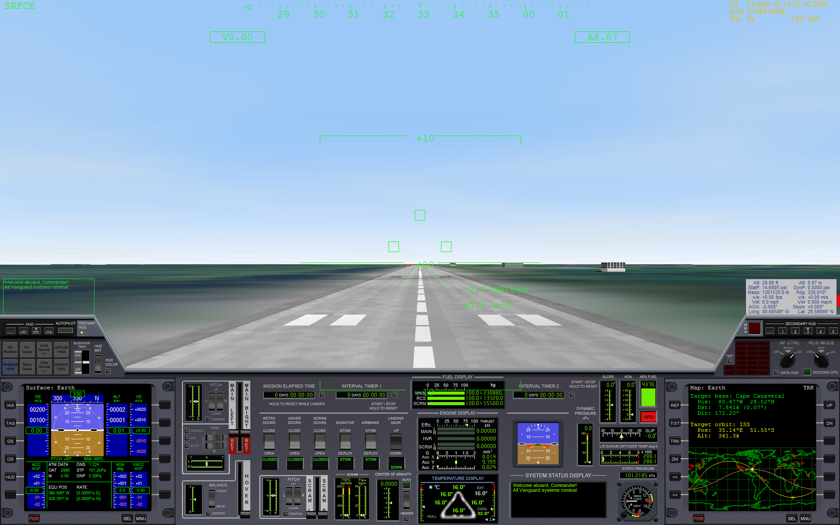

*1920x1200 Screenshot Showing the Vanguard’s Optional 1920-pixel-wide 2D Main Instrument Panel.*

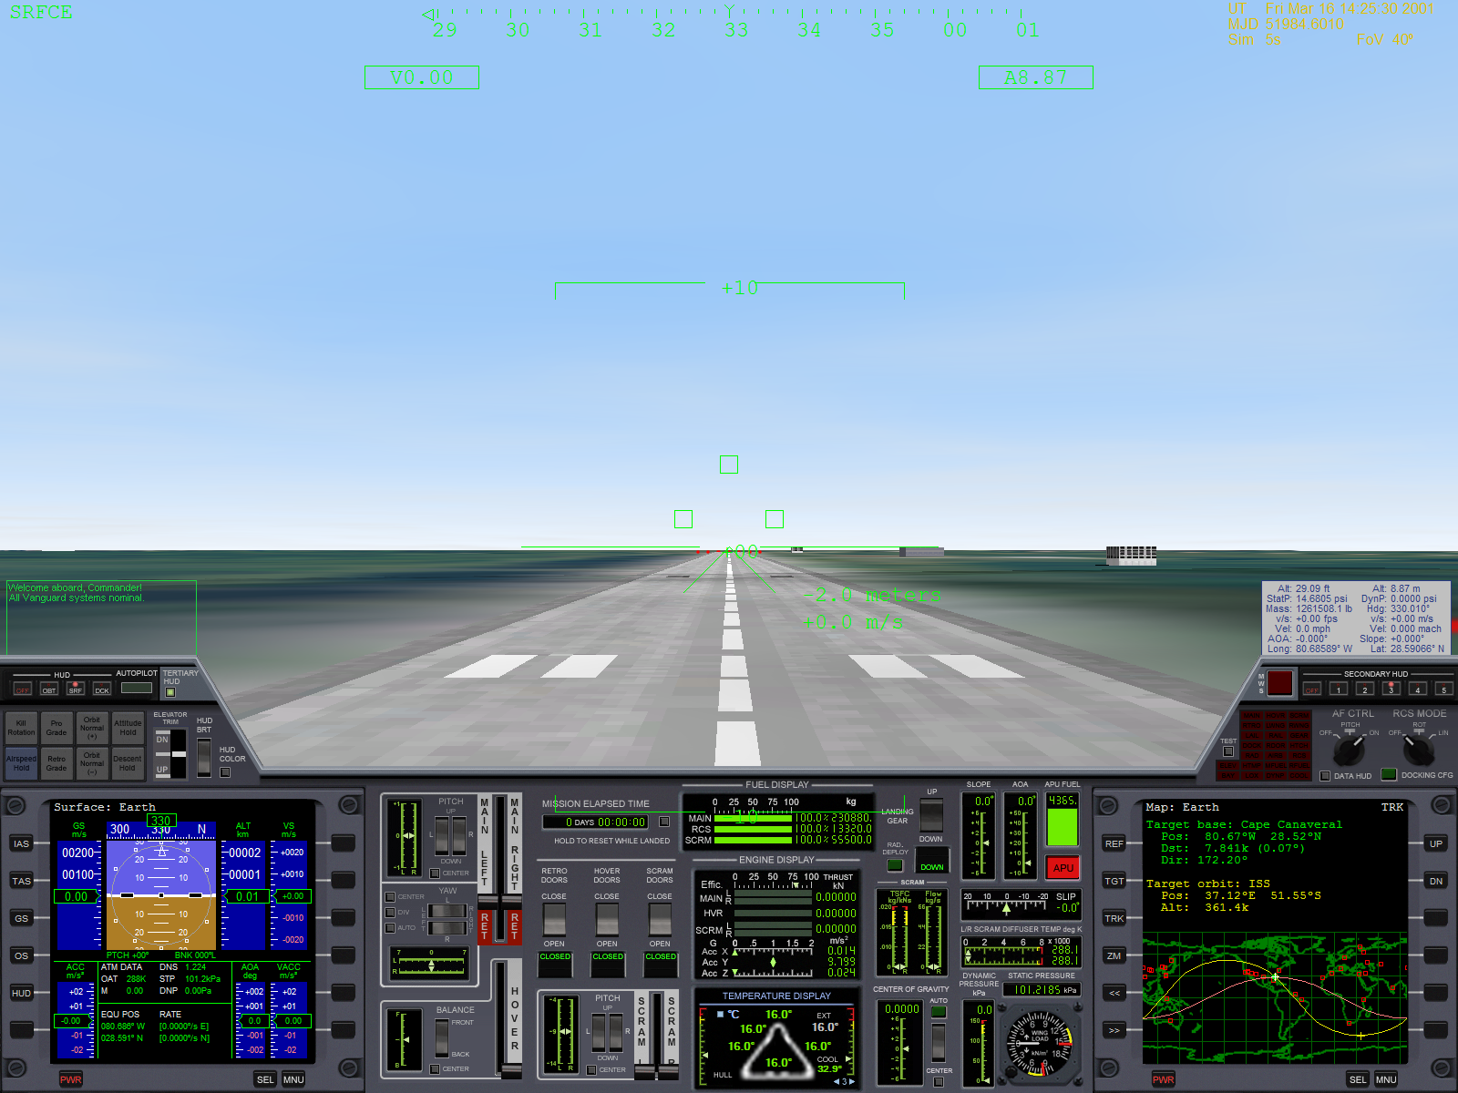

*1600x1200 Screenshot Showing the Vanguard’s Optional 1600-pixel-wide 2D Main Instrument Panel.*

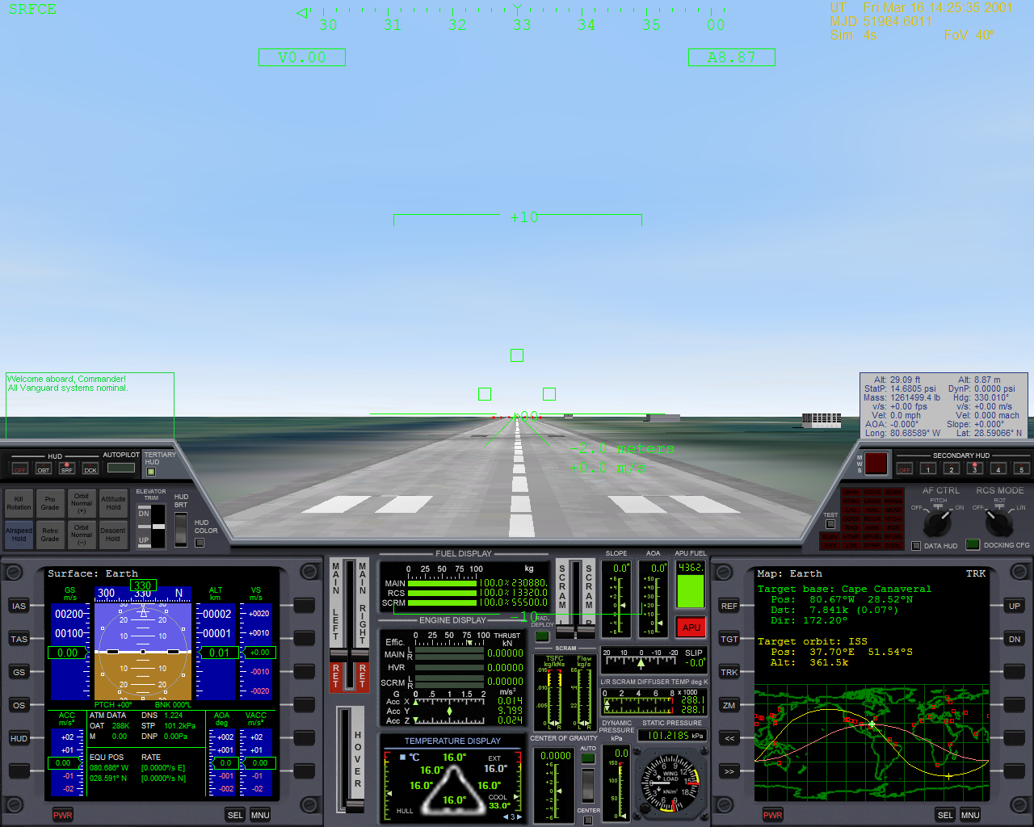

*1280x1024 Screenshot Showing the Vanguard’s Default 1280-pixel-wide 2D Main Instrument Panel.*

## Configuring Your XR Vessel

Each XR vessel includes a configuration file that lets you tailor your vessel’s behavior to your liking. Each file is fully commented, and each XR vessel allows extensive configuration of its settings. Note that you do not need to exit the Orbiter Launchpad in order for your edits to take effect; the configuration file is read every time a new vessel is created (i.e., each time a scenario loads).

XR vessels are high-performance spacecraft for Orbiter, however they share many common controls with standard Orbiter vessels: Orbiter’s default controls, such as virtual cockpit, throttle, and view controls are unchanged from the standard vessels included with Orbiter. You can refer to the DeltaGlider-S documentation included with Orbiter for details about standard flight and view controls: the file is C:\Orbiter\Doc\DeltaGlider.pdf.

By default each XR vessel is installed with all damage settings *enabled*, which means that it is now quite possible to destroy your ship if you don’t watch what you’re doing. However, damage detection and simulation is fully configurable via your vessel’s configuration file, and you are free to turn any particular damage type on or off as desired (*hull heating, hard landings, crashes, etc.*) If you turn off *all* damage settings, your XR vessel will be as forgiving as the default DeltaGlider included with the Orbiter core installation. This allows novice pilots to “ease into” realistic flight gradually as they progress.

*Note: XR configuration files are simple text files that you can edit with your favorite text editor (e.g., Notepad)*. The default XR vessel configuration files are shown in the table below:

|  |  |
| --- | --- |
| **XR Vessel** | **Configuration File** |
| DeltaGlider-XR1 | $ORBITER_HOME\Config\DeltaGliderXR1Prefs.cfg |
| XR2 Ravenstar | $ORBITER_HOME\Config\XR2RavenstarPrefs.cfg |
| XR5 Vanguard | $ORBITER_HOME\Config\XR5VanguardPrefs.cfg |

For example, to configure (disable) different types of ship damage you would edit the following parameters in your XR vessel’s configuration file and set one or more to zero to disable damage detection for that subsystem:

|  |
| --- |
| #----------------------------------------------------------------------  # Enable or disable ship damage due to wing stress, hull heating,  # hard landings, crashes, excessive dynamic pressure, and SCRAM  # engine overheat.  # 0 = damage disabled  # 1 = damage enabled  #---------------------------------------------------------------------  WingStressDamageEnabled=1  HullHeatingDamageEnabled=1  HardLandingsDamageEnabled=1  CrashDamageEnabled=1  DoorStressDamageEnabled=1  ScramEngineOverheatDamageEnabled=1  EnableDamageWhileDocked=1 |

In addition to editing the default configuration file for your XR vessel, which affects *all* of those types of vessels in *all* your scenarios (i.e., editing $ORBITER_HOME\Config\DeltaGliderXR1Prefs.cfg will affect all of your XR1 vessels in all scenarios), you can also override some or all of your default settings for just one scenario by modifying that scenario file. There are two different methods of doing this:

1. Rename your XR vessel in your scenario file to match the name of a corresponding $ORBITER_HOME\Config\<vesselname>.xrcfg override file, or
2. Add one or more CONFIG_OVERRIDE_<settingname> settings directly to the scenario file.

It is also possible to do *both* in a given scenario file,in which case configuration settings are applied in the following order:

1. The default configuration file (e.g., $ORBITER_HOME\Config\DeltaGliderXR1Prefs.cfg).
2. The override configuration file, if any (e.g., $ORBITER_HOME\Config\MyShipName.xrcfg).
3. Any CONFIG_OVERRIDE_<settingname> settings specified in the scenario file.

Settings applied *later* override any earlier settings. Each XR vessel includes example scenarios demonstrating how to override default settings using both methods:

Method 1: Scenarios\<shipname>\Configuration File Override Example 1.scn 🡪 uses a corresponding .xrcfg file.

Method 2: Scenarios\<shipname>\Configuration File Override Example 2.scn 🡪 sets CONFIG_OVERRIDE_ values in the scenario file.

The first method is generally preferred because you can override *any* XR preference setting by setting a custom value for it in the .xrcfg file(s) for the XR vessel(s) in that scenario. For technical reasons the second method is limited to overriding only the settings listed below:

CONFIG_OVERRIDE_MainFuelISP=#

CONFIG_OVERRIDE_SCRAMFuelISP=#

CONFIG_OVERRIDE_LOXConsumptionMultiplier=#

CONFIG_OVERRIDE_APUFuelBurnRate=#

CONFIG_OVERRIDE_CoolantHeatingRate=#

(…where # is a number for that configuration setting.)

If you need to override any other settings, or if want to easily apply a given group of settings to multiple scenarios, use method one instead.

As an example, let’s say you want to create a custom set of XR settings for a trip from Earth to Mars for your XR2. You don’t need to edit the default $ORBITER_HOME\Config\XR2RavenstarPrefs.cfg file, although you certainly may if you wish. If you would rather just create a custom configuration, however, there are two steps:

1. Create a new .xrcfg file in the Config directory what contains only those settings you wish to override. [Note that you can override as few or as many settings as you wish.] There is a pre-installed sample file for the XR2 demonstrating this named XR2-EXAMPLE.xrcfg.
2. Modify your Orbiter scenario file in which you want to use your new Mars-configured XR2 and rename the XR2 vessel to match the filename of the .xrcfg file you just created: XR2-EXAMPLE, in this case.

The sample Scenarios\XR2 Ravenstar\Configuration File Override Example 1.scn scenario file does just that. If you open that scenario in a text editor you will see our XR2 is named as follows:

XR2-EXAMPLE:XR2Ravenstar

STATUS Landed Earth

POS -80.705714 28.632274

HEADING 150.00

When you rename your XR2, be sure to replace *all* the occurrences of the old vessel name in the scenario file. For example, we also have this section near the end of the file:

XR2-EXAMPLE_Bay:XRPayloadBay

STATUS Landed Earth

POS -80.7098293 28.6270272

HEADING 149.98

ATTACHED 0:3,XR2-EXAMPLE

END

XR2PayloadCHM-01-1:XR2PayloadCHM

STATUS Landed Earth

POS -80.7098140 28.6270040

HEADING 149.98

ATTACHED 0:0,XR2-EXAMPLE

NAVFREQ 0 0

END

When that XR vessel loads in Orbiter, it will check whether a preference override file exists with this name: $ORBITER_ROOT\Config\XR2-EXAMPLE.xrcfg (the filename is case-insensitive). If the file exists, it will be read and any preference settings in it applied *after* the default configuration file is processed. Any XR vessels in any scenarios with the name XR2-EXAMPLE will use that .xrcfg file, so once the .xrcfg file is created you need only rename your XR vessel in a given scenario to match in order for it to use that configuration override file. This lets you share a single configuration file across multiple scenarios, so if you want to make a change to those settings you only need to edit the .xrcfg file to have it affect all scenarios (vessels) that use it; this is easier than editing each individual scenario file separately.

In our example here, our XR2-EXAMPLE.xrcfg override file contains these settings (comments snipped for brevity):

[GENERAL]

MainFuelISP=5

LOXLoadout=5

APUFuelBurnRate=1

All other preferences will use their default values as specified in the default configuration file, $ORBITER_HOME\Config\XR2RavenstarPrefs.cfg.

## Cheat Codes

For more adventurous pilots, XR vessels include a *CHEATCODES* section in their configuration files that allows users to directly set certain ship parameters such as ship mass, fuel capacity, engine thrust, etc. *Note that these values are not range-checked in any way.* Please be aware that although setting a *CHEATCODE* value incorrectly will not harm your Orbiter installation, it couldin theory cause Orbiter to CTD *(Crash-To-Desktop)* if some values are set incorrectly. Refer to the comments in your vessel’s configuration file for more information.

# Flying your XR Vessel

*Note: as stated in the standard Orbiter documentation:*

* *You may switch between different instrument panels (docking, upper, payload, main, lower) using the CTRL-UP / CTRL-DOWN / CTRL-LEFT / CTRL-RIGHT keys.*
* *To rotate knobs on the 2D panels, either use the shortcut keys or, if you prefer the mouse, left-click to turn them left and right-click to turn them right.*
* *You may switch between instrument panel modes (2D panel -> Virtual Cockpit -> Glass cockpit) via the F8 key. [Note that the XR5 does not have a virtual cockpit.]*
* *In Virtual Cockpit mode you may move between seats via the CTRL-arrow keys.*
* *You may toggle external view with the F1 key and then pan around by holding right-mouse button or page up/page down/CTRL-cursor keys.*

*For more information about standard Orbiter flight keys, view controls, and standard ship controls please refer to the standard C:\Orbiter\Doc\DeltaGlider.pdf and C:\Orbiter\Doc\Orbiter.pdf files installed with Orbiter.*

Although not required, the key to efficiently flying your XR vessel into LEO ("Low-Earth Orbit") is to use your air-breathing SCRAM engines for as long as possible before using your main engines for orbit insertion. A SCRAMJET is a variant of the conventional RAMJET engine (*Supersonic* RAMJET). Unlike jet engines, RAMJET engines have no compressor to compress the incoming air -- air is "rammed" into the diffuser where it is compressed and ignited with injected fuel. As such, SCRAM engines are ineffective at low velocities or even high velocities if the atmosphere is too thin.

If you fly too low you will waste fuel by generating excessive heat, possibly even damaging the ship if hull temperatures get too high. On the other hand, if you fly too high you will decrease SCRAM engine thrust and efficiency because there will be insufficient oxygen being rammed into the SCRAM intakes. The key to efficient flight is to gradually increase altitude as velocity increases, keeping dynamic pressure high enough to feed the SCRAM engines but low enough to not create excessive drag and heat.

To track your SCRAM engine efficiency, refer to the SCRAM TSFC/Fuel Flow gauge on the main panel; for TSFC, lower values are better.

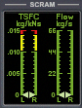

SCRAM TSFC and Fuel Flow Gauge on the Main Panel

Similarly, when firing the main engines, you may refer to the TSFC (*Thrust-Specific Fuel Consumption*) gauge on the *MAIN/HOVER* display on the lower panel to show how much fuel is consumed to produce a given amount of thrust: lower values are better.

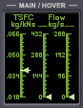

*Main/Hover TSFC and Fuel Flow Gauge on the Lower Panel*

The white horizontal line on the TSFC gauge shows the TSFC of the main and hover engines in a vacuum; i.e., it is the *maximum efficiency* line. The two fuel flow gauges to the right of the TSFC show the fuel flow rates of the *main* and *hover* engines, respectively, in kilograms-per-second.

A key gauge to watch during SCRAM ascent is the *Dynamic Pressure* gauge on the main panel.

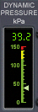

*Dynamic Pressure Gauge showing pressure in kilopascals*

Try to keep the dynamic pressure between 8 and 20 kPa (*kilopascals)* initially, depending on velocity. This will supply the SCRAM engines enough oxygen without the ship being too low in the atmosphere and generating excessive heat, which wastes fuel. If you fly your ascent correctly you should be able to reach Mach 17-20 before the engines reach their operational limit and you shut down the SCRAM engines and switch to the main engines for orbit insertion.

Another important gauge to watch during SCRAM ascent is the *SCRAM Diffuser Temp* gauge; this shows the temperature of the diffuser in each engine where the incoming air is compressed before it is combined with SCRAM fuel and ignited.

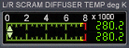

*SCRAM Diffuser Temperature Gauge*

The diffuser chamber walls are cooled by the cryogenic SCRAM fuel right before it is injected; the operational limit of the engines is 8000 Kelvin. Since the SCRAM engine is a RAMJET variant, the speed of the ship determines the temperature of the compressed air in the diffuser. As you approach thermal limits the temperature of the compressed freestream approaches the temperature of the ignited fuel/air mixture, and so the thrust produced (and therefore engine efficiency) is reduced. Once the engines reach their thermal limit they are unable to accelerate the ship any further; at that point you should shut down the SCRAM engines and switch to the main engines.

*Note: the computer will automatically throttle-down the SCRAM engines as the diffuser temperature approaches 8000 Kelvin, so don’t be afraid to run the engines right to the edge. As long as you don’t run the* main *engines alongside the SCRAMS the SCRAM engines will never overheat on an ascent running on SCRAM engines alone.* ***However, remember to close the SCRAM doors (CTRL-G, or use the switch on the upper panel) before you engage the main engines!*** *Otherwise, the diffuser temperature may exceed 8000K, which will overheat and likely damage the SCRAM engines. Excessively overheating the SCRAM engines may cause an explosion and destroy the ship.[1]*

To monitor your engine thrust and efficiency plus the G forces active on your ship, refer to the *Engine Display* on the main panel (shown below). The top line shows a gauge from 0-100. The green bars below it indicate 0-100% engine thrust for the Main, Hover, and SCRAM engines, respectively. The green arrow on the *Effic* Line shows your current main and hover engine efficiency; rocket engines are less efficient when flying in an atmosphere, and so you will see the arrow move to the right toward 100% efficiency as static pressure decreases during ascent in an atmosphere[2].

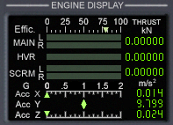

*Engine Display Gauge Landed on Earth*

The bottom part of the panel shows the G forces currently active on your ship. Orbiter uses a left-hand coordinate system, and so the X axis shows acceleration along the side-to-side axis, Y shows vertical acceleration (up-down), and Z shows forward/aft acceleration. A green arrow indicates positive acceleration (*right* for X axis, *up* for Y axis, and *forward* for Z axis), and red arrow indicates a negative acceleration (i.e., “deceleration”).

To monitor the fuel quantity remaining in your Main, RCS, and SCRAM tanks refer to the *Fuel Display* as shown below:

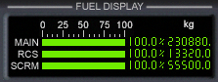

*Fuel Display Gauge with Full Tanks on the Vanguard*

Structural and Thermal Limits

This section details the structural and thermal limits of each XR vessel; remember that you can disable any or all of these limits by editing your vessels configuration file (e.g., XR5VanguardPrefs.cfg).

***XR Structural and Thermal Limits***

|  |  |  |  |
| --- | --- | --- | --- |
| **Description** | **DG-XR1** | **XR2 Ravenstar** | **XR5**  **Vanguard** |
| Max positive wing load | 17000 N/m^2 | 17000 N/m^2 | 17000 N/m^2 |
| Max negative wing load | 11000 N/m^2 | 11000 N/m^2 | 11000 N/m^2 |
| Max dynamic pressure (absolute) | 150 kPa | 150 kPa | 150 kPa |
| Landing Gear Energy Absorption Limit | 8.04e+4 kg m/s2 | 1.29e+5 kg m/s2 | 2.57e+6 kg m/s2 |
| Max touchdown descent rate, max load (full fuel, full cargo) | 3.1 m/s | 2.8 m/s | 2.6 m/s |
| Max touchdown descent rate, typical load (33% fuel, 75% cargo) | 5.8 m/s | 4.2 m/s | 3.5 m/s |
| Crew Survivability Limit (max vertical impact velocity) | 39 m/s | 39 m/s | 39 m/s |
| Max bank at touchdown | 15 degrees | 15 degrees | 15 degrees |
| Max pitch at touchdown | 16 degrees | 16 degrees | 16 degrees |
| Max dynamic pressure: Crew Elevator deployed | N/A | N/A | 9 kPa |
| Max dynamic pressure: Radiator Deployed | 16 kPa | 16 kPa | 16 kPa |
| Max dynamic pressure: Cabin Hatch deployed | 20 kPa | 20 kPa | 20 kPa |
| Max dynamic pressure: Docking Port/Nosecone open | 32 kPa | 32 kPa | 32 kPa |
| Max dynamic pressure: Payload Doors open | N/A | 36 kPa | 36 kPa |
| Max dynamic pressure: Landing Gear deployed | 39 kPa | 39 kPa | 39 kPa |
| Max dynamic pressure: Retro Doors deployed | 41 kPa | 41 kPa | 41 kPa |
| Hull Thermal Failure at temperature limit (single surface) | ~8 seconds (typical) | ~8 seconds (typical) | ~8 seconds (typical) |
| Max surface heating: NOSECONE | 2840 C  (5144 F) | 2840 C  (5144 F) | 2840 C  (5144 F) |
| Max surface heating: WINGS | 2380 C  (4316 F) | 2380 C  (4316 F) | 2380 C  (4316 F) |
| Max surface heating: COCKPIT | 1490 C  (2714 F) | 1490 C  (2714 F) | 1490 C  (2714 F) |
| Max surface heating: TOP HULL | 1210 C  (2210 F) | 1210 C  (2210 F) | 1210 C  (2210 F) |

**Notes:**

* Depending on the ship’s mass, exceeding the max descent rate at touchdown will collapse the landing gear and damage the hover engines, and may injure or kill the crew; exceeding the limit by too much will destroy the ship.
* Exceeding a surface’s dynamic pressure limits will overload that surface's hydraulics causing them to fail. **WARNING: AN OPEN (DEPLOYED) SURFACE SEVERELY COMPROMISES THAT SURFACE'S HEAT RESISTANCE.**
* The high-strength SCRAM and Hover doors do not have a dynamic pressure limit (except for the hull's absolute dynamic pressure limit, of course); however, the hover doors must be CLOSED during reentry to prevent the inner hull from overheating. Similarly, you must close the SCRAM doors for high-Mach (> Mach 17-20) upper atmospheric flight.
* If a hull surface overheats, typical failure occurs within eight seconds at temperature limit; failure probability increases by overtempRatio2 as hull temperature increases.
* **WARNING: If a door is open on a surface, that surface's thermal limit is much lower: 480 C**

# Custom Shortcut Keys

This section lists the custom shortcut keys defined by XR Vessels. Note that the standard Orbiter shortcut keys are not listed here; please refer to the standard documentation bundled with the Orbiter core distribution for details about standard shortcut keys.

Note that not all keys are applicable to all ships; for example, the XR1 does not have a payload bay, and so payload keys are not applicable to that vessel.

## XR Vessel Custom Shortcut Keys

|  |  |
| --- | --- |
| ALT-, | Shift center-of-gravity aft. |
| ALT-. | Shift center-of-gravity forward |
| ALT-M | Re-center center-of-gravity |
| ALT-U | Deploy selected payload |
| CTRL-ALT-U | Deploy all payload |
| ALT-G | Grapple selected payload |
| CTRL-ALT-G | Grapple all payload |
| ALT-J | Toggle DOCKING/NORMAL RCS config (*XR5 only*) |
| CTRL-E | Toggle crew elevator (*XR5 only*) |
| CTRL-U | Toggle payload bay doors |
| F1 | Toggle exterior view |
| ALT-SPACE (hold) | Show DATA HUD (XR custom keyboard shortcuts) |
| CTRL-A | Auxiliary Power Unit (APU); supplies hydraulic power |
| CTRL-B | Airbrake |
| ALT-R | Radiator |
| CTRL-K | Nose Cone / Docking Port |
| CTRL-\ | Retro doors (opening = low-pitched beep, closing = high-pitched beep) |
| CTRL-G | SCRAM doors (opening = low-pitched beep, closing = high-pitched beep) |
| CTRL-V | Hover doors (opening = low-pitched beep, closing = high-pitched beep) |
| CTRL-O | Outer airlock |
| CTRL-Y | Cabin hatch |
| G | Gear |
| CTRL-W | Reset MWS Warning Light and Alarm (you can also click the blinking MWS light) |
| L | Toggle Attitude Hold / Auto-Land autopilot; replaces stock LEVEL HORIZON autopilot. |
| A | Toggle Descent Hold autopilot; replaces stock HOVER HOLD ALT autopilot. |
| ALT-S | Toggle Airspeed Hold autopilot; note that Airspeed Hold may be engaged simultaneously alongside (i.e., independently of) any other autopilot. |
| CTRL-= or ALT-NUMPAD+ | Increase SCRAM throttle |
| CTRL-- or ALT-NUMPAD- | Decrease SCRAM throttle |
| ALT-= | Small increase SCRAM throttle (1/10th normal) |
| ALT-- | Small decrease SCRAM throttle (1/10th normal) |
| CTRL-BACKSPACE or ALT-NUMPAD* | Kill SCRAM thrust |
| SHIFT-NUMPAD_INS | Small increase hover throttle (1/10th normal) |
| SHIFT-NUMPAD_DEL | Small decrease small hover throttle (1/10th normal) |
| CTRL-NUMPAD* | Kill hover thrust |
| CTRL-. | Increase elevator trim level |
| CTRL-, | Decrease elevator trim level |
| SPACE | Disengage autopilot |
| / | Same as NUMPAD "/"; workaround for Joy2Key bug. |
| CTRL-/ | Same as NUMPAD "CTRL-/"; workaround for Joy2Key bug. |
| ALT-/ | Same as NUMPAD "ALT-/"; workaround for Joy2Key bug. |
| ALT-X | Increase HUD brightness |
| ALT-Z | Decrease HUD brightness |
| ALT-H | Change HUD color |
| ALT-T | Toggle secondary HUD on/off |
| CTRL-[1-5] | Switch to secondary HUD mode [1-5] (also turns on HUD in that mode) |
| CTRL-T | Toggle tertiary HUD on/off |
| [0-9] | Switch to MultiDisplayArea Mode #(0-9) |
| D | Next MultiDisplayArea Mode |
| ALT-D | Previous MultiDisplayArea Mode |
| ALT-; | Main & SCRAM engines gimbal up (nose up) |
| ALT-L | Main engines gimbal right (nose left) |
| ALT-P | Main & SCRAM gimbal down (nose down) |
| ALT-' | Main engines gimbal left (nose right) |
| ALT-0 | Re-center main engines gimbal controls |

**Notes:**

* "CTRL-", "CTRL=", and BACKSPACE on the main keyboard are recommend for controlling the SCRAM throttle; those keys are easier to use than the ALT-NUMPAD keys when flying with a joystick.

When one of the three custom autopilot modes is engaged, certain autopilot-specific keys become activated. The following sections list each of the three custom autopilot modes and the keys used by each.

## XR Attitude Hold Shortcut Keys

|  |  |
| --- | --- |
| L | Toggle *Attitude Hold* on or off |
| CTRL-L | Engage *Attitude Hold* and sync to current attitude |
| NUMPAD2 | Increment pitch/AOA hold by 2.5 degrees |
| NUMPAD8 | Decrement pitch/AOA hold by 2.5 degrees |
| ALT-NUMPAD2 | Increment pitch/AOA hold by 0.5 degree |
| ALT-NUMPAD8 | Decrement pitch/AOA hold by 0.5 degree |
| NUMPAD6 | Increment bank hold by 5 degrees |
| NUMPAD4 | Decrement bank hold by 5 degrees |
| CTRL-NUMPAD3 | Zero bank (reset bank to level) |
| CTRL-NUMPAD7 | Zero pitch (reset pitch to level) |
| CTRL-NUMPAD1 | Zero both (reset bank and pitch to level) |
| NUMPAD9 | Toggle between *AOA Hold* and *Pitch Hold* modes. |

## XR Descent Hold Shortcut Keys

|  |  |
| --- | --- |
| A | Toggle *Descent Hold* on or off |
| CTRL-NUMPAD2 | Decrease descent rate 2.5 m/s |
| CTRL-NUMPAD8 | Increase descent rate 2.5 m/s |
| NUMPAD2 | Decrease descent rate 0.5 m/s |
| NUMPAD8 | Increase descent rate 0.5 m/s |
| ALT-NUMPAD2 | Decrease descent rate 0.1 m/s |
| ALT-NUMPAD8 | Increase descent rate 0.1 m/s |
| NUMPAD0 | Engage AUTO-LAND mode (efficient, gentle auto-touchdown using hover engines) |
| NUMPAD. | Engage HOVER mode (hold altitude) |

## XR Airspeed Hold Shortcut Keys

|  |  |
| --- | --- |
| S | Toggle *Airspeed Hold* on or off |
| CTRL-NUMPAD+ | Increase rate 25 m/s |
| CTRL-NUMPAD- | Decrease rate 25 m/s |
| NUMPAD+ | Increase rate 5 m/s |
| NUMPAD- | Decrease rate 5 m/s |
| SHIFT-NUMPAD+ | Increase rate 1 m/s |
| SHIFT-NUMPAD- | Decrease rate 1 m/s |
| ALT-NUMPAD+ | Increase rate 0.1 m/s |
| ALT-NUMPAD- | Decrease rate 0.1 m/s |
| NUMPAD_ENTER | Hold current airspeed (also useful after NUMPAD* to hold a lower speed; i.e., “resume”) |
| NUMPAD* | Reset rate to 0 m/s (i.e., "coast") |

# Center-of-Gravity Shifting

XR Vessels use center-of-gravity shifting and elevator trim in addition to RCS jets to manage the ship’s pitch during reentry and atmospheric flight. If the *Attitude Hold* or *Descent Hold* autopilot is engaged the computer will control COG shifting automatically. If you want to manage COG shifting yourself, ensure that the *Attitude Hold* and *Descent Hold* autopilots are disengaged.

If *Attitude Hold* or *Descent Hold* is engaged, the flight computer will use COG shifting in conjunction with elevator trim and RCS jets to maintain attitude, which allows the ship to hold a stable reentry profile even under time acceleration. Also, it is extremely efficient and uses very little RCS fuel. Attitude Hold also performs well in atmospheric flight (for example, during SCRAM ascent). The ship is also very stable when transitioning from conventional flight to hover while Descent Hold is engaged.

Note that the pumps that pump fuel forward or aft for COG shifting require a lot of power, and therefore the APU must be active in order for them to operate. The APU must be active in order for the elevator trim to operate as well. If the APU is offline and *Attitude Hold* or *Descent Hold* is engaged in an atmosphere, by default the ship will auto-start the APU so that COG shifting and elevator trim control can occur. If you want to disable this feature, set APUAutostartForCOGShift=0 in your vessel’s preference file.

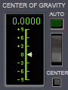

*Center-of-Gravity Controls on the Main Panel*

# Using the Multi-Display-Area (MDA)

XR vessels are equipped with a touch-screen *Multi-Display-Area (MDA)* in the lower center of the main panel. This panel supports 10 different modes (0-9), with each mode having its own touch-screen virtual buttons and other information. The picture below lists MDA Mode #3:

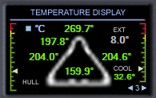

*MDA Mode 3 (Temperature Display)*

Notice the solid light blue areas on the screen: those areas are touch sensitive. You can use the blue arrows on either side of the **3** in the lower-right corner to step to the next or previous MDA mode. You can also select an MDA mode *directly* by via the keys 0-9, and you can step to the next or previous MDA mode by using the **D** and **ALT-D** keys, respectively.

The other interactive area on the above MDA screen is the solid blue block next to the °C indicator: clicking it will switch the display between Celsius, Fahrenheit, and Kelvin temperature scales. Except for the blue navigation arrows in the lower-right corner, the interactive areas for each MDA mode are different; you will find each MDA mode detailed in its relevant section later in this manual.

# Walkthrough: Launch from KSC to Low-Earth-Orbit

Here is walkthrough detailing how to fly your XR vessel from Kennedy Space Center efficiently into LEO *(Low-Earth-Orbit)*:

1. In the Orbiter Launchpad, select your vessel’s *Ready for takeoff to ISS* scenario in your vessel’s scenario folder (e.g., *XR5 Vanguard*). You are lined up on the runway at KSC.
2. Ensure that the APU (*Auxiliary Power Unit*) is powered on (it is controlled by the APU button or CTRL-A). The APU powers your hydraulic systems. Also ensure that the *AF CTRL* switch is set to *ON*; if you forget to do this and you are taking off in an atmosphere, a warning callout occurs.
3. If you will be taking off immediately, skip this step. Otherwise, if you want to wait for more than a few minutes before taking off, enable e*xternal cooling* via the switch on the lower panel to keep the ship's internal systems cool. You can monitor the internal coolant temperature on the lower panel or on the main panel on the MDA screen, mode 3 (it should currently be displayed by default). You should also shut down your APU (CTRL-A or click the button on the panel) so you don’t waste any APU fuel. If you want to conserve onboard oxygen as well, open the cabin hatch via CTRL-Y or the switch on the upper panel.



*Multi-Display-Area (MDA) Mode #3*

*The right-hand gauge shows the ship’s internal coolant temperature: 32.6 degrees Centigrade. The remainder of the display shows external hull temperatures, which are discussed later.*

1. Once you reach your takeoff time, power up the APU again, close the cabin hatch, and disable external cooling via the switch on the lower panel. Also double-check that *AF CTRL* is set to *ON*. You will need to keep the APU online until you reach about 75 km altitude and switch to RCS jets for attitude control.
2. Ready for takeoff! Push the main engines to full power. You will notice the Y axis G meter fluctuating as you roll down the runway; this is normal.
3. The computer will call out *100 knots*, then *V1* (which is *Takeoff Decision Speed*), and finally *Rotate:* pull up when *rotate* is called out and press ALT-S to engage Airspeed Hold, or throttle back to about 40% manually. As the ship goes airborne, by default the computer will call out *Wheels Up*, which is a pilot term that means "the wheels are off the ground." It does *not* mean that the gear has been retracted. *NOTE: you can change or disable the liftoff and touchdown callouts by editing your vessel’s configuration file; refer to the* LiftoffCallout *and* TouchdownCallout *properties in the file for details.*
4. Once you are airborne raise the gear with **G**. Turn smoothly to 136 degrees (or whatever your ascent heading is), level out, press SPACE BAR to disengage Airspeed Hold, and push the main engines to full power. Pitch up to about 70 degrees. **Do not engage the SCRAM engines yet!** As you accelerate you will hear a sonic boom as you pass through Mach 1 unless you have disabled the sonic boom sound in your vessel’s configuration file.
5. Once you approach 24-28 km altitude, level out smoothly and begin to accelerate to Mach 3.5 (XR1/XR2) or Mach 4.5 (XR5) and open the SCRAM doors if they are not already open (CTRL-G or use the switch on the upper panel). Adjust the elevator trim controls to maintain level flight (*CTRL-.* and *CTRL-,* or *INS* and *DEL*). Once you reach your target velocity, push the SCRAM engines to full power and gradually throttle back the main engines until they are shut down. Keep an eye on the thrust generated by the SCRAM engines; if you throttle back the main engines too soon, the SCRAM engines will not be able to accelerate the ship by themselves. Adjust the elevator trim controls to maintain about +100 m/s *(meters-per-second)* ascent. If you want to you may engage the *Attitude Hold* autopilot at this point (**CTRL-L**) to maintain a smooth ascent profile.
6. As you accelerate uphill keep an eye on the *Dynamic Pressure* gauge: it should read about 35 kPa at 24 km at Mach 4. Adjust your climb rate via elevator trim to gradually decrease dynamic pressure until it reaches ~10 kPa at 40 km altitude. Then adjust elevator trim or Attitude Hold settings to maintain 10kPa. *Note: you may need to adjust your ascent profile somewhat depending on the vessel you are flying and its payload* *mass.*
7. When the sky becomes dark, switch your secondary HUD mode to mode 2 (press the **2** Secondary HUD button or press *CTRL-2* on the keyboard). This will switch to a transparent HUD with different data fields useful during ascent. Remember that you can customize each of the five secondary HUD modes via your vessel’s configuration file.

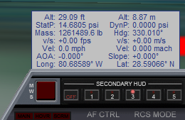

*Default Secondary HUD Mode 3*

*By default, the five secondary HUD modes are configured for (1) reentry, (2) ascent, (3) atmospheric flight, (4) docking, and (5) on-orbit operations. You may customize all five secondary HUD modes by specifying which data fields to display for each mode as well as the color and transparency settings for each mode in your XR vessel’s configuration file (e.g.,* XR5VanguardPrefs.cfg*)*.

1. You will notice the fuel flow and, correspondingly, the thrust for the SCRAM engines, increase as velocity increases up until the fuel flow reaches the maximum flow rate. The flow rate determines the maximum amount of fuel the engine can burn, and therefore the maximum thrust the engine can produce.
2. You will also notice as speed increases the SCRAM TSFC (*Thrust-Specific Fuel Consumption*) will go down, which means the engines are being more efficient. As speed increases beyond Mach 7-9, however, engine efficiency will gradually decrease. This is normal and is due to a combination of two factors: 1) the shape and design of the engines, and 2) the decreasing delta between the compressed freestream temperature and the SCRAM burner temperature as velocity increases.
3. Use elevator trim (*CTRL-,* and *CTRL-.* or *INS* and *DEL*) to maintain a smooth, gradual ascent as you accelerate. Adjust ascent rate to keep dynamic pressure around 10 kPa. Try to fly smoothly by making small adjustments to the elevator trim. As your velocity and altitude increase, adjust your ascent rate to keep lowering dynamic pressure gradually below 10 kPa down to about 4 kPa. For optimum efficiency, you want to have enough oxygen for the SCRAM engines to operate at peak thrust but still have minimal extra air resistance.

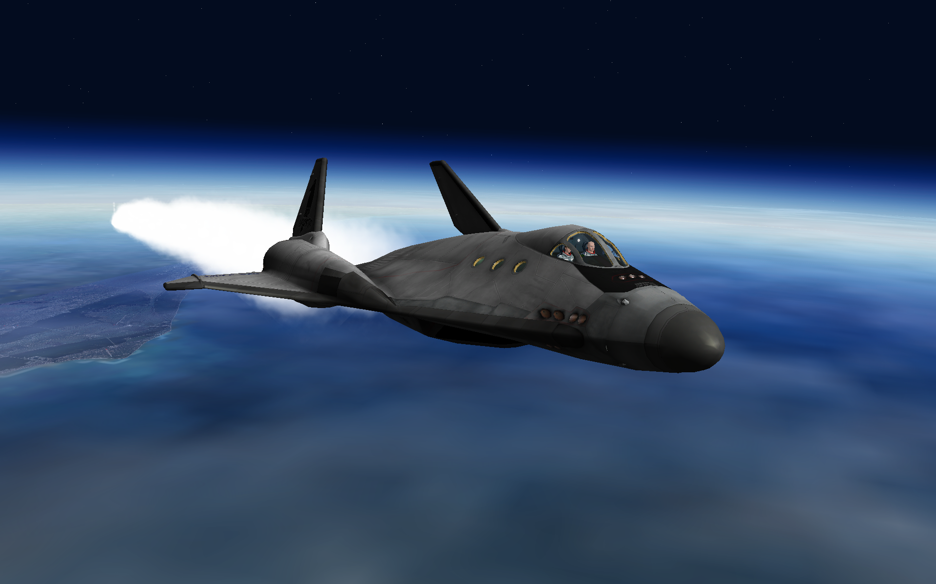

*XR2 Ravenstar on SCRAM Ascent*

1. If you fly your ascent correctly (and assuming no payload), at about 60 km you should reach Mach 20+ before the SCRAM engines approach their thermal limit or run out of fuel, with ~60% main fuel remaining (with the default fuel ISP settings). You may want to keep a few percent of your SCRAM fuel in reserve in case you need it later during reentry if you are short of the base by a few hundred kilometers. If that occurs, remember to engage the SCRAM engines at velocities greater than Mach 4, and preferably about Mach 7-9; below Mach 4, the TSFC is much higher because the engines make much less thrust for a given amount of fuel. The engines operate at peak efficiency around Mach 7-9.
2. Once you shut down the SCRAM engines, **close the scram doors!** (*CTRL-G*, or use the switch on the upper panel.) If you don't do this and you engage the main engines, the SCRAM engines will begin to overheat because the temperature of the diffuser (which compresses the incoming air) is directly proportional on the velocity of the freestream. Overheating the SCRAM engines may damage them or even destroy the ship if you overheat them too much!
3. After you close the SCRAM doors, push the main engines to full power and pitch up about 10 degrees initially. Then adjust pitch to enter your desired orbit as you ascend smoothly. Once your apoapsis altitude (ApA on the Orbiter MFD) reaches 200 km, shut down the main engines. Note that you are not in orbit yet, but you have to wait until you reach apoapsis (the “high point” of your orbit) before burning your main engines again to raise your periapsis (the “low point” of your orbit).
4. Deploy the radiator (*ALT-R*, or use the green button the main panel or the switch on the upper panel) and re-center the elevator trim (*CTRL-.* or click on the elevator trim area on the panel). Once the radiator is fully deployed, the green *RAD DEPLOY* light will come on. Switch *AF CTRL* to *OFF* and shut down the APU to conserve its fuel (*CTRL-A*, or click the APU button).
5. It will take up to 45 minutes in real-time to reach your apoapsis (which is the point where your vertical speed goes from positive to zero to negative). You can use accelerated time (**T** and **R** keys) to speed up the process.
6. As you approach apoapsis, engage the PROGRADE autopilot (**[** key, or use the *Prograde* autopilot button on the main panel) and engage the main engines gradually *just before* you reach apoapsis: this will raise the low point of your orbit. Be careful to not engage your main engines too soon or you will raise your *apoapsis* (the *high* point of your orbit) as well, which is not what you want! Once your periapsis (PeA on your Orbit MFD) reaches 200 km, cut your main engines.

At this point, if you've done everything correctly you should be in a stable 200x200 km orbit. Congratulations, you have achieved orbit!

Or you can just forget finesse and run the main and SCRAM engines simultaneously during ascent and accelerate at 3-5 Gs…

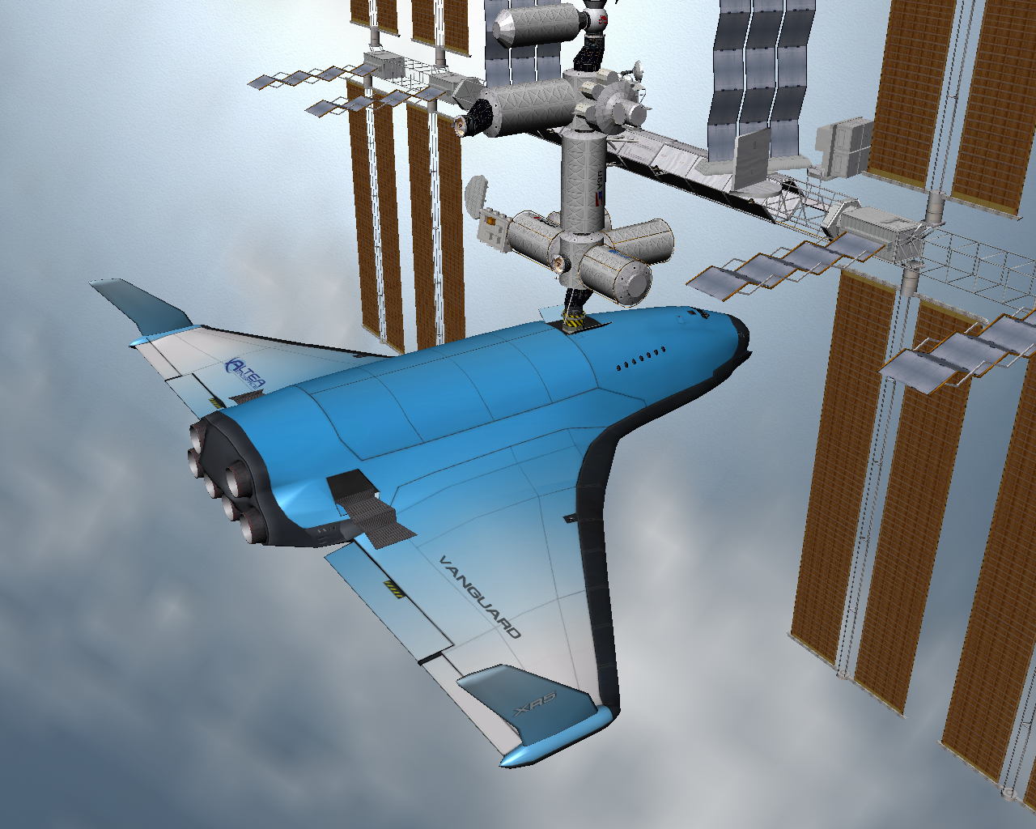

*XR5 Vanguard Docked at the ISS*­­

Fuel and Oxygen Consumables Management

XR vessels support built-in refueling when you are docked with any vessel or landed on any planet or moon; no fuel MFD or other add-on is necessary. Refueling and LOX *(Liquid Oxygen)* resupply settings are fully configurable via you’re your vessel’s configuration file (e.g., XR5VanguardPrefs.cfg); the default configuration is to allow MAIN fuel refueling and LOX resupply when docked with any vessel or landed on any planet or moon, but you may only resupply SCRAM and APU fuel when landed on Earth (since you only need significant amounts of SCRAM and APU fuel when in an atmosphere). You may change any of this behavior as desired by editing the config file.

To refuel or resupply you must be landed or docked and your XR configuration settings must be set to allow refueling and/or LOX resupply for your location. For example, you could configure your vessel to only allow refueling on the **ground** and *never* while **docked**.

## Replenishing Fuel and LOX Tanks

1. After docking (or landing and coming to a full stop), switch to the lower panel and open the fuel and/or LOX hatches depending on whether you want to resupply fuel, LOX, or both.

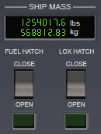

*Ship Mass Display and Resupply Hatch Switches*

1. You will hear the external fuel and/or LOX hatches open, followed by a thump when the external lines connect and magnetically lock. You will see pressure build on the *EXTERNAL LINE PRESSURE* gauges. When pressure reaches nominal for each line the green light below the gauge will come on.

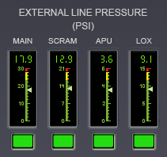

*All Supply Lines Green!*

1. At this point there is pressure in the fuel lines, so refer to the *EXTERNAL SUPPLY LINES* switches on the lower left-center of the panel. Click the *MAIN/SCRAM/APU/LOX* switches as desired to feed consumables to that tank (picture is below). To resupply the RCS tank, set the *X-FEED* switch to *RCS* to cross-feed fuel in the main tank to the RCS tank.

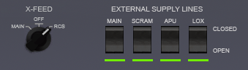

*Resupply in progress; filling RCS tanks as well.*

*Hint: If you are low on main engine fuel during a mission and have some RCS fuel to spare, you can cross-feed RCS fuel over into the main tank by setting the X-FEED switch to MAIN and cross-feeding fuel until only a small amount of RCS fuel remains. However, be sure to keep enough RCS fuel in reserve to finish the mission!*

*Hint: You can dump fuel and/or LOX [usually done only before reentry to lighten the ship] by holding down the dump button below the main gauge. Note that you must HOLD the button down to initiate the fuel dump. Tap the button again to halt the fuel dump.*

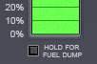

*Fuel Dump Button*

**Note: Main/RCS Engine Fuel, SCRAM Fuel, and APU Fuel are not compatible. Fuel may only cross-feed between the MAIN and RCS tanks.**

1. When you flip the switch for a supply line you will see the line pressure drop and fluctuate slightly as fuel or LOX flows into the tank; this is normal. Note that line pressure will be *higher* when refueling on the ground than when refueling while docked; line pressure affects the speed at which the tank fills, so refueling will take longer when docked than when on the ground.
2. You can monitor the ship's mass as fuel or LOX is loaded via the *SHIP MASS* display on the lower panel. Refueling continues until you close the supply line via its switch, close the fuel or LOX hatch, or move the ship with thrusters (which disconnects the lines). Each supply line switch will also automatically close when the tank it feeds is full. The only exception to this is when the main tank is full but is still cross-feeding into the RCS tank; at that point refueling will continue until the RCS tank is also full, at which point the main supply line feed will close automatically.
3. When you are finished resupplying, close the fuel and LOX hatches; you are now ready for takeoff!

Note that the ship will switch over to external Oxygen (*O2*) when you are 1) docked with both airlocks open, or 2) landed on Earth with both airlock doors or the crew hatch open. It is a good idea to do this whenever possible because it will help to conserve your onboard oxygen supply.

## XR2/XR5 Only: Using Payload Bay Fuel/LOX Tanks

XR vessels that have a payload bay can also attach and use auxiliary fuel and/or LOX tanks in the payload bay. There are three types of consumables tanks available:

1. Main fuel bay tank
2. SCRAM fuel bay tank
3. LOX bay tank

These tanks vary by XR vessel, but they all function in the same way: when bay tanks are attached, your fuel/LOX gauges are updated to reflect the increased fuel load, and bay tanks will drain before your internal tanks. Some additional notes:

* If you attach a non-empty bay tank, fuel from the bay tank will fill the main tank.
* Each bay tank's fuel/LOX load is preserved in the scenario file.
* If you dump consumables from your ship with bay tanks attached, the *bay* tanks drain first.
* If you resupply consumables with bay tanks attached, the ship’s *internal* tanks fill first and then any *bay* tanks.

# Coolant Temperature Management

XR vessels’ internal electronics and computers are cooled via a liquid cooling system. The coolant reserves are able to absorb a certain amount of heat, but this heat must eventually be dissipated away from the ship via the radiator or a ground-based or station-based external cooling system. If not, the internal computers and systems will overheat and fail, causing the computers which regulate environmental systems to fail as well. Once this occurs cabin oxygen will no longer be replenished and the crew will lose consciousness or even die if cabin oxygen levels fall below about 10%.

To manage coolant temperature it is important to deploy the radiator as soon as possible after reaching orbit. If you are landed or docked you may also enable the external cooling system, which works by connecting an external coolant line from a ground- or station-based cooling system. External cooling is somewhat more efficient than the radiator, and if you are landed or docked you may also enable *both* systems simultaneously to cool the ship at more than twice the rate of the radiator alone. External cooling is activated via a switch on the lower panel.

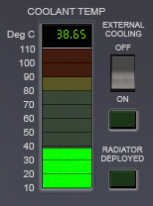

*Coolant Temperature Gauge*

*Note: running the APU will increase heat generation by several percent (as well as burn APU fuel), so be sure to shut down the APU when you don't need it.*

Be sure not to deploy the radiator in flight in an atmosphere because excessive dynamic pressure may damage it, rendering it unable to cool the ship any further. *If that happens, land immediately because once the internal systems overheat cabin oxygen flow will fail!* Once you land, open the crew hatch or both airlock doors to replenish oxygen levels in the cabin, and enable external cooling to cool the ship’s systems.

You can monitor coolant temperatures on the main panel via the *Temperature Display* MDA screen (described earlier), or you may refer to the *COOLANT TEMP* gauge on the lower panel as shown above. If coolant temperature reaches **80C** you will hear a warning message. If coolant temperature reaches approximately **90C** internal systems may fail; failure will typically occur within 20 seconds, although it may vary. Once the system overheats, the MDA screen, MFDs, HUDs, and environmental systems will fail. *At this point you must deploy the radiator ASAP because you only have a few minutes before oxygen levels fall too low and the crew becomes unconscious and dies shortly thereafter.*

Note that coolant management may be configured or disabled via the config file.

You can monitor the cabin oxygen levels via the *OXYGEN REMAINING* screen on the lower panel.

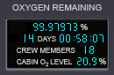

*O2 Remaining Display*

Oxygen time remaining is of course proportional to the number of crew members onboard the ship.

# APU Fuel Management

The APU (*Auxiliary Power Unit*) provides hydraulic power to the ship. It powers flight control systems, doors, radiator deployment, etc. You will normally only run the APU during takeoff and landing in an atmosphere, reentry, or you will run it for a short time when you need to open or close an airlock door or the payload bay doors.

Unless APU fuel consumption is disabled via the *APUFuelBurnRate* setting in the ship’s config file, the APU has limited fuel so be efficient with its use and don't leave it running when you don't need it.

If you attempt to take off in an atmosphere with the APU off you will hear a warning callout from the computer.

Because the APU is the sole source of hydraulic power on XR vessels, the APU must be running in order for these systems to operate:

* + Airlock Ladder
  + Docking Port/Nosecone
  + Outer Airlock Door
  + Inner Airlock Door
  + Airbrake
  + Cabin Hatch
  + Radiator
  + Retro Doors
  + Landing Gear
  + Payload Bay Doors
  + Crew Elevator
  + Flight Control Surfaces (elevons, rudder, elevator trim, etc.)
  + Wheel Brakes

Nominal APU startup/shutdown time is 2.5 seconds.

As a safety feature, if you leave the APU running for more than 60 seconds with no load on it (i.e., without using it) you will hear a warning callout from the computer. This warning interval may be changed or eliminated via the *APUIdleRuntimeCallouts* in your vessel’s configuration file. Note that if *APUFuelBurnRate=0* (unlimited), APU idle warning callouts are automatically disabled.

Also note that by default the APU will automatically shut down whenever you switch focus to another vessel *unless* an XR autopilot that requires APU power is engaged. If desired, you may disable auto-APU shutdown by setting *APUAutoShutdown=0* in your vessel's configuration file.

You may activate the APU via *CTRL-A* or via the APU button present on the ship's 2D instrument panels.

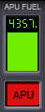

*APU Button and Fuel Gauge*

# M.E.T. and Interval Timers

XR vessels feature a *Mission-Elapsed-Time* (MET) timer plus two manual interval timers. The MET timer will start automatically once the ship goes "wheels-up", meaning "at liftoff". The MET timer will run until you land again and manually reset it by holding down the reset button. Note that you may only reset the MET timer while landed – you may *not* reset it merely while docked to another vessel or while in flight. Once it is reset it will start again automatically at liftoff.

The two interval timers are similar to the MET timer except that they may be started, stopped, or reset anywhere at any time. The first interval timer is on the upper panel and the second interval timer is on the lower panel; these timers run independently of each other.

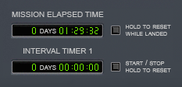

*Upper Panel Timer Displays*

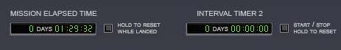

*Lower Panel Timer Displays*

# Damage and Warning Display

This section details the damage and warning displays in XR vessels. First and foremost, there is a warning display on the main panel in addition to a *Master Warning System (MWS)* light that alerts you to a problem. This panel varies slightly between XR vessels, but it functions similarly on all XR vessels.

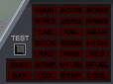

*XR5 Vanguard Master Warning System Indicator Lights*

The MWS panel is present on both the main and lower instrument panels. To silence the audible alarm, press *CTRL-W* or click the MWS button/light. Hold down the *MWS TEST* button to test the warning indicator lights.

Also note that the APU button will blink steadily if the APU is low on fuel.

The indicator warning lights refer to the following systems (listed from top-left to lower-right):

***XR5 Vanguard Master Warning System Indicator Lights***

|  |  |
| --- | --- |
| Elev | Crew Elevator |
| Bay | Payload Bay Doors |
| main | Main Engines |
| hovr | Hover Engines |
| scrm | SCRAM Engines |
| rtro | Retro Engines |
| lwng | Left Wing |
| rwng | Right Wing |
| lail | Left Aileron |
| rail | Right Aileron |
| gear | Landing Gear |
| Dock | Docking Port |
| rdor | Retro Doors |
| htch | Cabin Hatch |
| rad | Radiator |
| airb | Airbrake |
| rcs | Reaction Control System (14 jets) |
| htmp | Hull Temperature |
| Mfuel | Main Fuel |
| Rfuel | RCS Fuel |
| lox | Liquid Oxygen (O2) |
| dynp | Dynamic Pressure |
| cool | Coolant Temperature |

To obtain more specific information about damaged systems, use the five *Systems Status* MDA modes (modes 5-8).

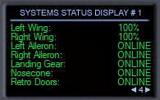

*MDA Mode 4 (Systems Status Display #1)*

# Attitude Hold Autopilot

XR vessels include a highly accurate and efficient *ATTITUDE HOLD* autopilot that can hold a given pitch or AOA (*Angle of Attack)* and bank setting while neutralizing yaw via a *yaw dampener*. It is MDA mode 2; use the MDA arrows and click the *Engage* button, or use **L** to engage it via the keyboard (more on this later). This high-precision autopilot replaces the stock *Level Horizon* autopilot.

Note that ATTITUDE HOLD may be used at any time, not just for reentry. For example, it is useful to hold 87.5 degrees pitch while you are braking with the hover engines approaching a landing site in a vacuum (for example, at Brighton Beach). In addition, some pilots like to use ATTITUDE HOLD during SCRAM ascent to hold a given pitch and bank.

The autopilot constantly neutralizes yaw while it is engaged; however, you may “nudge” the ship’s yaw using the joystick rudder or the *NUMPAD1*/*NUMPAD3* keys; the yaw dampener will momentarily disengage whenever the pilot manually induces yaw and automatically reengage when the pilot stops inducing yaw.

There are two different modes to hold the ship along the Y axis: *Pitch Hold* and *AOA Hold*. In *Pitch* mode the autopilot will hold a set pitch. Conversely, in *AOA* mode the autopilot will hold a given *Angle of Attack*. Typically you will only use *AOA* mode when reentering in an atmosphere and use *Pitch* mode the rest of the time. You may toggle between modes by clicking the blue block in the top-right corner of the screen, or you may use *NUMPAD9* when the autopilot is engaged.

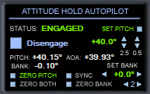

*ATTITUDE HOLD Autopilot Engaged in Pitch Mode*

*NOTE: except during reentry, if you engage ATTITUDE HOLD during atmospheric flight be sure to engage Pitch mode to hold a given pitch rather than AOA mode to hold a given angle of attack: in atmospheric flight the ship’s angle of attack will constantly decrease with the autopilot engaged (this is normal!), and so AOA mode will cause the ship to constantly increase pitch trying to maintain the set angle of attack. You should only engage AOA mode for reentry!*

For ship stability reasons maximum bank and pitch are normally limited by ATTITUDE HOLD to +/- 60 degrees or between +120 and (crossing the 180-degree boundary) -120 degrees. However, with zero bank you can hold a pitch up to +/-87.5 degrees, and with zero pitch you can hold a bank up to +/-75 degrees or between +105 and (crossing the 180-degree boundary) -105 degrees. *Note: to* prevent the pilot from accidentally flipping the ship over during reentry you must temporarily disengage A*ttitude Hold before you can jump the bank setting from +/-60 to +/-120 degrees and vice-versa.*

The *Zero Pitch, Zero Bank,* and *Zero Both* buttons will reset pitch, bank, and *both axes* to zero, respectively. [Note that if the ship is currently banked at more than +/-90 degrees *Zero Bank* will level the ship at 180 degrees (“upside down”).] In addition, *Zero Pitch* will read *Zero AOA* if AOA mode is engaged.

The *Sync* button will automatically update the bank and pitch/AOA target values to the ship's current values; i.e., it will “sync” the autopilot settings to the ship’s current attitude. The shortcut key to engage ATTITUDE HOLD and automatically sync to (i.e., "hold") your current attitude is *CTRL-L*.  "L" by itself toggles ATTITUDE HOLD on or off.

*Note: unlike the CTRL-L shortcut key, the* Sync *button on the MDA screen will not automatically engage the autopilot; therefore, you will normally only use the* Sync *MDA button before engaging the autopilot. If you want to immediately “lock” the ship in its current attitude, use CTRL-L instead.*

One final note about *Sync*: the pitch/AOA and bank limits for sync mode are +/-60 degrees or between +120 and -120 degrees (crossing 180 degrees; e.g., *+120 -> +180 -> -120*); do not engage *Sync* outside those limits. If you do, the ship will engage ATTITUDE HOLD at the nearest 60-degree or 120-degree boundary.

## Reentry Walkthrough

Before you reach the atmosphere during reentry, be sure that the radiator is retracted and all doors are closed! Bring up MDA MODE 9 (*Reentry Systems Check*) by pressing **9**, or use the MDA arrows. Close any doors flagged by the reentry check. Once all systems show GREEN you are ready for reentry!

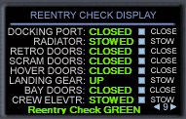

*MDA Mode 9 (Reentry Systems Check) on the XR5 Vanguard*

Before reaching entry interface, turn PROGRADE to ensure your ship is aligned with the ship’s velocity vector and then switch to the *Attitude Hold* MDA screen (mode 2) by pressing **2** on the keyboard or using the MDA screen arrows. Ensure that AOA Mode is engaged (the top-right should read *SET AOA*), and then set your desired AOA; typically you will initially set 40 degrees AOA and 0 degrees bank. Engage the ATTITUDE HOLD autopilot with **L** or by clicking the *Engage* button on the touch screen. Be sure you have enough APU fuel remaining to reach your landing site! The APU must remain online to power the center-of-gravity shift pumps and flight control surfaces.

Once Attitude Hold is engaged you may change your AOA in 2.5- or 0.5-degree increments by clicking the pitch arrows on the MDA screen or via the *NUMAPAD8, NUMPAD2, ALT-NUMPAD8* and *ALT-NUMPAD2* keys. You may change your bank in 5-degree increments by clicking the bank arrows or via the *NUMPAD4* and *NUMPAD6* KEYS. Refer to the *Custom Shortcut Keys* section earlier in this document for a detailed list of autopilot mode keys.

*Note: You may also hold down the mouse button on the pitch/AOA and bank arrows to rapidly scroll the pitch and bank rates. The ship's current pitch, AOA, and bank are displayed on the MDA screen.*

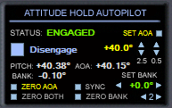

*ATTITUDE HOLD Autopilot Engaged in AOA Mode*

With bank set to 0 degrees you can hold a maximum pitch of +/- 87.5 degrees; with bank set to non-zero, you can hold a maximum pitch of +/- 60 degrees. Similarly, with pitch set to 0 degrees you can hold a maximum bank of 75 degrees; with pitch set to non-zero, you can hold a maximum bank of 60 degrees.

**A NOTE ABOUT TIME ACCELERATION:**

With a decent frame rate (60 fps or higher) you should be able to run the *ATTITUDE HOLD* autopilot at 100x in space and 4x in an atmosphere, even during reentry: great care was taken to make the autopilot as fuel-efficient and stable as possible. If you attempt to engage time acceleration at 1000x in space or 100x in at atmosphere, the autopilot will switch to SUSPENDED status (this will be shown on the MDA screen); it will automatically re-engage when you switch back to a lower time acceleration again.

As you reenter the atmosphere you should typically hold 35-45 degrees AOA. NOTE: be sure your ship's mass is not too great -- if the ship is too heavy you will likely overheat your hull! Use the fuel and/or LOX dump buttons on the lower panel to lighten your ship if necessary. For a nominal one-degree-slope reentry and assuming a normal payload your fuel mass should be under 50%, although it is possible to “baby the ship down” with a higher ship mass if you expertly vary your pitch to reduce the rate of aero-braking.

As you enter the denser part of the atmosphere keep an eye on your hull temperatures! The vertical gauge on the left side of the *Temperature MDA* screen (mode 3) is especially useful because it shows you exactly how close your hottest surface is (percentage-wise) to going over-temp. This makes it easy to see exactly how close you are to overheating your hull. If the indicator reaches the top, one of your hull surface temps is over maximum and you will shortly damage or even destroy your ship!

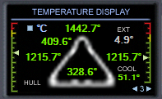

*Temperature Display (MDA Mode 3)*

From top-to-bottom and left-to-right, the hull temperatures displayed are:

* NOSECONE
* COCKPIT (i.e., Cabin hatch)
* LEFT WING
* RIGHT WING
* TOP HULL

The *EXT* value shows the temperature outside the ship, which may be either atmospheric temperature or temperature in vacuum.

If you exceed the maximum safe temperature on one or more of your hull surfaces the hull begins to weaken and will fail, on average, within about eight seconds if hull temperatures are not reduced below maximum. Note that the higher you are over-temp the faster the hull will (on average) fail, and overheating more than one surface will increase the chances of hull failure proportionally.

Note: It is theoretically possible to breach the hull anytime you are over-temp -- there is no hard-coded "minimum time" or “maximum time”. Typically you will have about eight seconds if you are right on the threshold and only have one surface that is over-temp; however, the average time-to-breach will be lower if you are significantly over-temp (percentage-wise) for a given surface. Also, the more surfaces you have over-temp the more likely that one of them will breach. For example, if you have four surfaces over-temp instead of just one, your ship will have four times as many chances for a hull breach than if only one surface is over-temp (assuming each surface is percentage-wise equally over-temp). Furthermore, 200 degrees C over-temp on the *wings* is only 8.4% over maximum, but 200 degrees C over-temp on the *cockpit* is 13.4% over maximum. The more you are over-temp on a surface, the higher your odds of a hull breach on that surface: being just slightly over-temp is less likely to cause a hull breach, but it is still possible at any time when you are over-temp.

Temperature readouts are displayed as follows:

|  |  |
| --- | --- |
| GREEN | OK |
| YELLOW | temp >= 80% of maximum sustained temperature |
| RED | temp >= 90% of maximum sustained temperature |
| WHITE | **OVER-TEMP! The hull will likely fail within a few seconds if heat is not reduced. The hotter the hull gets, the more likely it is to fail.** |

Remember to keep an eye on your internal coolant temperature as well, which is the gauge on the right-hand side of the display. (This was detailed earlier in the *Walkthrough: Launch from KSC to Low-Earth-Orbit* section.)

# Descent Hold Autopilot (Hovering and Landing)

XR vessels include a highly accurate and efficient *DESCENT HOLD / AUTO-LAND* autopilot that can hover or hold a specified ascent or descent rate within 1/100th of a meter-per-second (0.01 m/s). It is MDA mode 1; use the MDA arrows and click the *Engage* button, or use **A** to engage it via the keyboard. This high-precision autopilot replaces the stock *Hover Hold Altitude* autopilot.

*NOTE: before engaging the DESCENT HOLD autopilot, be sure that the hover doors are open: if the hover doors are closed or if you close them with the hover engines running, the hover engines will shut down and the DESCENT HOLD autopilot will disengage. You can toggle the hover doors with CTRL-V or by using the switch on the upper panel.*

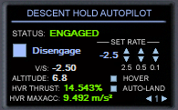

*DESCENT HOLD Autopilot Engaged*

You will notice there are three sets of *SET RATE* arrows labeled 2.5, 0.5, and 0.1. Clicking these will adjust the configured ascent/descent rate by 2.5, 0.5, and 0.1 meters-per-second, respectively. You can set any rate between -990 m/s and +990 m/s.

Also notice the *HOVER* and *AUTO-LAND* buttons: *HOVER* will reset the rate to 0.0 m/s, and *AUTO-LAND* will switch to auto-landing mode to efficiently and smoothly land your ship. If you attempt to engage *DESCENT HOLD* but the ship is too heavy for the hover engines to maintain the requested ascent or descent rate you will immediately receive a warning message stating that there is insufficient hover thrust available. For example, you will get this message if you attempt to lift off from Earth using *Realistic* hover engine settings (this is set in the config file) with more than about 50% fuel remaining.

The shortcut keys to set the ascent/descent rate are detailed in the *Custom Shortcut Keys* section earlier in this document; for example *CTRL-NUMPAD2* will decrease the descent rate by 0.1 m/s, *NUMPAD2* by itself will decrease it by 0.5 m/s, and *ALT-NUMPAD2* will decrease it by 2.5 m/s. Refer to the *Custom Shortcut Keys* section earlier in this document for a detailed list of autopilot mode keys.

Once you are hovering over your target landing site and you want to auto-land, you can either land the ship yourself by setting the descent rate or you can engage auto-land mode at any point to have the autopilot land the ship efficiently and smoothly. Once the wheels touch down the autopilot will automatically disengage and shut down the hover engines, whether or not auto-land mode is engaged. To auto-land, click the *AUTO-LAND* button on the MDA screen or press *NUMPAD0* when the autopilot is engaged. Press *NUMPAD0* again to disengage auto-land and revert to hover mode. You can also use *NUMPAD.* (numpad-dot) to engage hover mode at any time.

There are four values of interest displayed on the *Descent Hold* MDA screen:

|  |  |
| --- | --- |
| V/S | Shows vertical speed in meters-per-second. |
| ALTITUDE | Shows altitude in meters with 1/10th-meter resolution. |
| HVR THRUST | Shows the current hover engine thrust level from 0% to 100%. |
| HVR MAXACC | Shows the maximum acceleration that the hover engines can provide to the ship; i.e., it is the maximum braking force that the hover engines can provide. If this is < 0 it means the ship is too heavy to hover! |

**A NOTE ABOUT TIME ACCELERATION:**

With a nominal frame rate (~60 fps) you should be able to run the *DESCENT HOLD* autopilot at 100x in space and 10x in an atmosphere; you can even *AUTO-LAND* at up to ~80x time acceleration (the exact value depends on your frame rate rate). If you attempt to engage time acceleration at 1000x in space or 100x in at atmosphere, the autopilot will switch to *SUSPENDED* status (this will be shown on the MDA screen); it will automatically re-engage when you switch back to a lower time acceleration setting.

# Airspeed Hold Autopilot

XR vessels include a highly accurate and efficient *AIRSPEED HOLD* autopilot that can hold a given airspeed to within 0.1 meter-per-second in atmospheric flight or while taxiing. It is MDA mode 0; use the MDA arrows and click the *Engage* button, or use **ALT-S** to engage/disengage it via the keyboard.

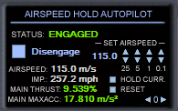

*AIRSPEED HOLD Autopilot Engaged*

You will notice there are four sets of *SET AIRSPEED* arrows labeled 25, 5, 1, and 0.1. Clicking these will adjust your set airspeed by 25, 5, 1, and 0.1 meter(s)-per-second, respectively. You can set any positive target velocity; however, depending on atmospheric drag and/or gravity the engines will not necessarily be able to reach the target airspeed. If the engines are unable to accelerate the ship any further a warning callout will sound.

Also notice the *HOLD CURRENT* and *RESET* buttons: *HOLD CURRENT* will set the target airspeed to your current airspeed, and RESET will reset the target airspeed to zero (i.e., the ship will "coast"). You can also use *NUMPAD_ENTER* to automatically engage *HOLD CURRENT*, *and NUMPAD\** to reset the target airspeed to zero.

If the target airspeed is zero and you engage the *Airspeed Hold* autopilot, the system will automatically engage and hold your current airspeed.

Note that the autopilot will never apply RETRO thrust: this is a design decision in the interests of efficiency; *Airspeed Hold* is designed to be used in an atmosphere or while taxiing. However, you may engage it in a vacuum if you want to accelerate smoothly and precisely to the indicated speed -- provided that you are facing in the direction of the ship's velocity vector (i.e., *prograde*).

The shortcut keys to set the target airspeed are detailed in the *Custom Shortcut Keys* section earlier in this document; for example *CTRL-NUMPAD+* will increase the target airspeed by 25 m/s, *NUMPAD+* by itself will increase it by 5 m/s, *SHIFT-NUMPAD+* will increase it by 1 m/s, and *ALT-NUMPAD+* will increase it by 0.1 m/s (useful while taxiing). *NUMPAD-* performs the inverse of *NUMPAD+*. Refer to the *Custom Shortcut Keys* section earlier in this document for a detailed list of autopilot mode keys.

There are four values of interest displayed on the *Airspeed Hold* MDA screen:

|  |  |
| --- | --- |
| AIRSPEED | Shows current airspeed in meters-per-second. |
| IMP | Shows current airspeed in Imperial miles-per-hour. |
| MAIN THRUST | Shows the current main engine thrust level from 0% to 100%. |
| MAIN MAXACC | Shows the maximum acceleration that the main engines can provide to the ship; if atmospheric drag and/or gravity drag is too high the engines will not be able to accelerate the ship any further and a warning callout will sound. |

The *Airspeed Hold* autopilot will automatically disengage when you touch down, so you don't need to worry about disengaging it if you use it during final approach.

*Airspeed Hold* is particularly useful during final approach when landing in an atmosphere:

1. Set *Airspeed Hold* to maintain about 110-130 meters-per-second, depending on your ship’s mass.
2. Fly the ship to a smooth touchdown on the runway without touching the throttle.
3. Apply the brakes by holding the **.** (period) and **,** (comma) keys.
4. Once the ship reaches wheel-stop, the parking brakes will engage automatically. Engaging any thruster or powering down the APU will automatically disengage the parking brakes.

**A NOTE ABOUT TIME ACCELERATION:**

You should be able to run the *Airspeed Hold* autopilot between 10x and 100x in an atmosphere, depending on your frame rate. If you attempt to engage time acceleration at > 100x the autopilot will switch to *SUSPENDED* status (this will be shown on the MDA screen); it will automatically re-engage when you switch back to a lower time acceleration setting.

# Using the Docking Camera (XR5 Only)

The Vanguard features a *docking camera and instrument panel* that makes docking with stations and other vessels much easier than it is for other Orbiter vessels with a dorsal (i.e., "top-mounted") docking port. Here is a screenshot of the docking camera view with the Vanguard on final docking approach to the ISS:

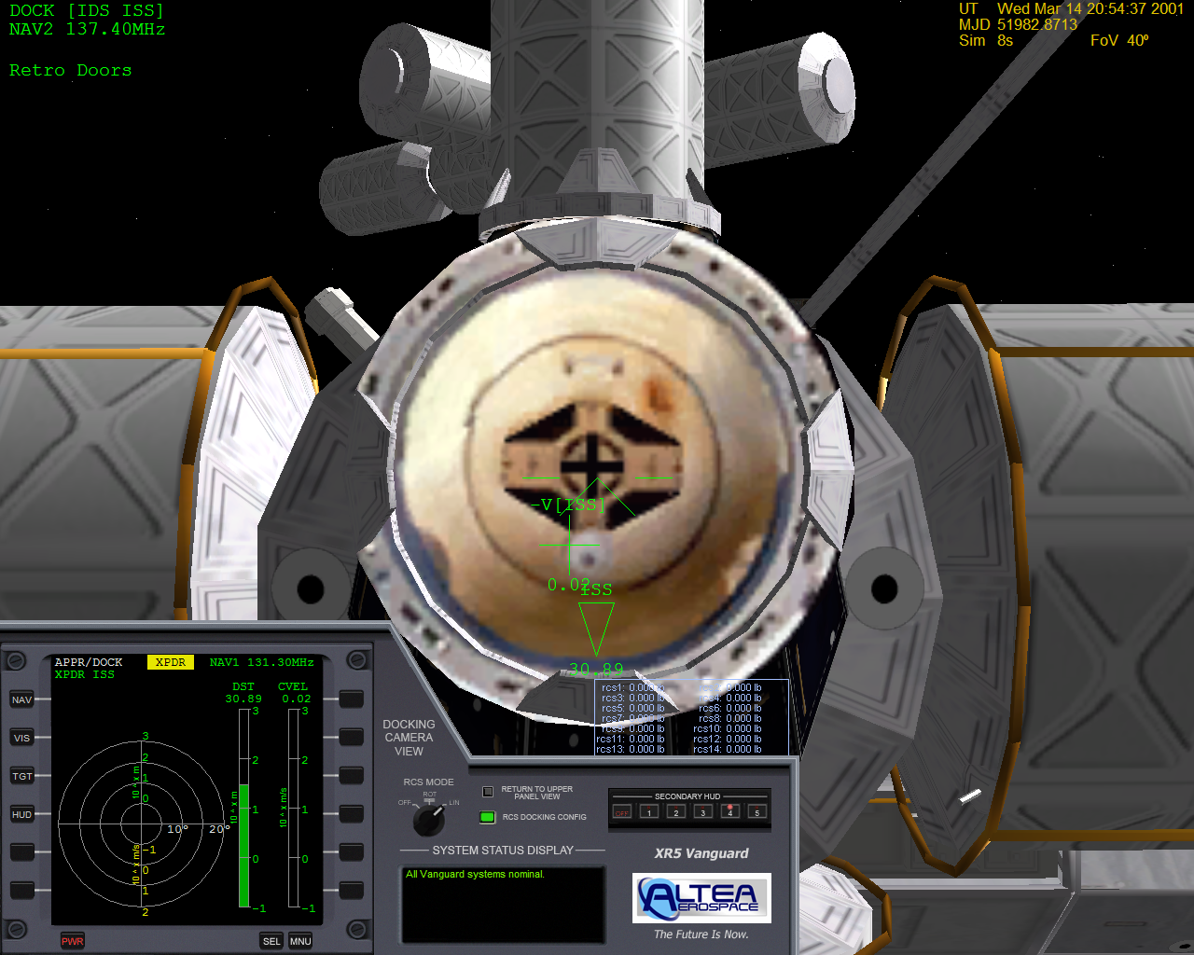

*Docking Camera View of Final Approach to the ISS*

You can access the docking panel by pressing CTRL-UP from the upper panel view (i.e., press CTRL-UP *twice* from the main panel), or you can use the *Switch to Docking Camera View* button on the upper panel. The docking camera is mounted directly along the centerline of the Vanguard’s docking port.

In addition to the docking camera, the Vanguard can switch the RCS jets into *docking configuration*. This is controlled via the *RCS Docking Config* button/light on the main panel and the docking camera panel, or you can use the ALT-J hotkey. Clicking the button toggles the RCS configuration between *Normal* and *Docking* modes: in normal mode the RCS jets operate normally. In *docking* mode, however, two changes occur: 1) power to the RCS jets is reduced to 40% of normal to allow for precise control of the ship while docking, and 2) the control axes for the RCS jets are switched so that when you are looking along the docking port centerline camera you can use the RCS Rotation and Translation keys just as though you were looking along the *nosecone* with a *nosecone* docking port; i.e., it will feel "normal." For example, pressing NUMPAD6 in translation mode will move the ship forward along the Z axis in *normal* RCS mode, but it will move the ship up along the Y axis in *docking* RCS mode.

As you approach the docking port you have tuned in your docking MFD, you will hear distance callouts from the computer as you approach. After docking port contact you may open your inner and outer airlock doors to use the station’s oxygen supply in order to conserve onboard oxygen if you wish. If you want to EVA the crew, you can use the crew elevator and take a spacewalk around the station. Refer to the chapter titled *Performing an EVA* for details.

# Payload Management (XR2/XR5 Only)

The XR2 Ravenstar and XR5 Vanguard feature cutting-edge payload support that makes it easy (and fun!) to transport cargo from one place to another in the solar system. The XR5 Vanguard is designed to carry up to 432,000 kg (432 metric tons) of payload, and while the XR2 Ravenstar is primarily designed as a “luxury Learjet” craft, it can carry up to 10.8 metric tons of cargo. It is possible to carry a heavier payload, but that would exceed the vessel’s maximum rated load and so it is not recommended.

To display the payload camera/instrument panel view, press CTRL-LEFT from the upper panel view or use the *Switch to Payload Camera View* button on the upper panel. Once you are in the payload camera view you may switch back to the upper panel via the *Return to Upper Panel View* button on the left side, or you may press one of the following hotkeys:

* CTRL-UP = Switch to Docking Camera view (XR5 only)
* CTRL-RIGHT = Switch to Upper Panel view
* CTRL-DOWN = Switch to Main Panel view

Any Orbiter vessel/payload module that can fit in the XR vessel’s payload bay can be latched into the bay, transported, and deployed either in orbit or while landed at a surface base (or anywhere else you land).

**XR5 Vanguard Only:**

For the Vanguard, payload is managed by attaching cargo modules into one or more of the Vanguard’s 36 bay slots, each of which is the size of a standard shipping container: 2.43 meters wide (X), 2.59 meters high (Y), and 6.09 meters long (Z). When a cargo module is attached in the bay it occupies one or more bay slots depending on its size. For example, if a cargo module is 3.0 meters wide it will occupy two bay slots *across* in the bay (X dimension) because it is wider than a single slot (2.4 meters). The only exceptions to this are the center slots in the Vanguard’s bay: they are slightly wider than standard bay slots, and measure 3.65 meters wide instead of 2.43 meters wide. With our example here, a payload module that is 3.0 meters wide would only occupy *one* center slot, but *two* normal slots (assuming the payload module is less than or equal to one slot in length [Z dimension], of course).

The Vanguard has a total of 36 bay slots across a total of three levels in the bay: level one contains 20 slots, level two contains 12 slots, and level three contains 4 slots.

A good scenario to use to see how payload management works is the *In Orbit With Payload* scenario in the *XR5 Vanguard* scenario folder.

**XR2 Ravenstar Only:**

The XR2 includes three payload bay slots: the forward slot (slot #1) is designed to carry the CHM (*Crew Habitat Module*), which contains living space for the crew. The two aft slots (2 & 3) are the same size and are designed primarily to carry auxiliary main fuel/SCRAM fuel/LOX, although other custom payloads may be attached as well.

Slot #1’s dimensions are 3.452 meters wide (X), 2.418 meters high (Y), and 2.060 meters long (Z). This is designed to carry the CHM; other payloads are not recommended because then the crew would have very limited living space.

Slot #2 and #3 are 3.452 meters wide (X), 2.128 meters high (Y), and 1.454 meters long (Z).

Note that all XR payloads are interchangeable between different ships *provided* that the payload will fit in the bay.

## UCGO Support

The XR fleet does not support UCGO cargo modules natively: since UCGO does not use attachment points to manage cargo and has a limit of 40 UCGO cargo modules per vessel, natively integrating it with the XR payload system would be a prohibitive amount of work as well as severely limit the XR5's carrying capacity. However, Woo482 has written UCGO Cargo Deck XR payload modules for the XR2 and XR5 that allow you to carry up to six (XR2) or 288 (XR5) UCGO cargo modules by using multiple XR cargo vessels (payload racks) to get around UCGO's 40-payload-module-per-vessel limit. You may find a link to Woo482's latest UCGO Cargo Decks on the *User Downloads* page on my Web site here: <https://www.alteaaerospace.com/index-4.html>

## Grappling Payloads

The XR payload management system makes it easy to load or unload cargo modules in orbit or while landed. To grapple (“load”) an existing cargo module, you must first select a grapple target that is within a certain distance of your ship. To do that, you should first refer to the *Grapple Payload* touch-screen: you will see a *Set Range* button and a value in meters. This setting determines the maximum range that payload will be shown in the *Target* list just below the button. The default is 50 meters, but you may step through different ranges to make it easier to find your desired payload module by filtering out payload modules that are farther away. Next, click on the blue *Target* up/down arrows to step through all cargo modules in range: the targeted module’s information will be displayed on the screen and its thumbnail will be displayed on the *Target Payload* screen on the right.

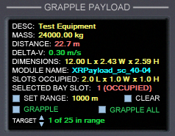

*Grapple Payload Touch-Screen*

Once you find the module you want to grapple you need to select an empty bay slot into which the payload will be attached: click on a square in the *Select Bay Slot* touch-screen. For the Vanguard, you may switch between payload bay slot levels (1-3) by clicking the *LEVEL* button on the bottom of the touch screen.

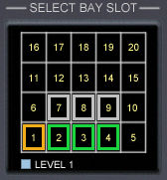

*XR5 Vanguard’s Select Bay Slot Touch-Screen*

Bay slot block border colors are as follows:

|  |  |
| --- | --- |
| **Block Border Color** | **Indicates** |
| Orange | The selected slot is occupied. |
| Cyan | The selected slot is empty. |
| Green | Unselected slot is occupied, and a payload module is attached in that slot. This is also called the *primary* slot for the occupying payload module, since it is the slot into which the payload module was originally attached. |
| Gray | Unselected Slot is occupied, but the payload module occupying it is attached in an adjacent slot. Gray slots cannot be selected: to deploy payload that is occupying a gray slot you must select that payload’s *primary* slot instead (which will be green). |

Once you have selected a free slot and you have maneuvered within grappling range of your targeted module you are ready to grapple the payload into the bay. In order to grapple your targeted module, however, the following conditions must be met:

1. The module must be within grappling range, which by default is about 22.0 meters[3] from the center of the vessel to the center of the payload module while in orbit, or 400 meters[4] while landed.
2. The ship must be within 0.5 meter-per-second delta-V to the cargo module.
3. You must have selected an empty bay slot that has enough free slots surrounding it for the module to fit (if the module is larger than one slot).

If you click the *GRAPPLE* button and any of the above conditions are not met, an error callout will occur and a detailed error message will be displayed. Note that you can also use the *GRAPPLE ALL* button to automatically grapple all targets in range into the bay, starting at the lowest free slot number and working upwards. The largest payloads in range are automatically grappled *first* in order to make the most efficient use of space.

You may also use the ALT-G hotkey to grapple a single target or CTRL-ALT-G to *grapple all*.

Once the target is grappled you will see your ship’s mass increase accordingly, and the selected bay slot will automatically increment to the next-higher free slot. This allows you to quickly grapple successive modules without having to keep selecting another free slot. This is particularly useful if you are in an external view and are using the ALT-G hotkey to grapple cargo while landed.

Note that the grappling procedure is the same whether you are in orbit or landed.

If you grapple a consumables tank (main fuel/SCRAM fuel/LOX) your ship’s consumables gauges will reflect the updated quantity. Remember that bay tanks drain *first* and fill *last*. For more information, refer back to the section titled *Using Payload Bay Fuel/LOX Tanks*.

## Deploying Payloads

Deploying a payload that is attached in the bay is, for the most part, the reverse of grappling a payload. You must first select a bay slot that contains the cargo module you want to deploy: this slot will be green before you select it and will turn orange when you click on it. As before, use the *LEVEL* button (if applicable) on the *Select Bay Slot* touch-screen to select the bay level of your target payload, then click the bay slot itself to select it.

The *Deploy Payload* touch-screen will display details about the attached payload you have selected (i.e., the payload slot that is highlighted in orange on the *Select Bay Slot* screen). If you are in orbit the touch-screen will display a delta-V setting and arrows as shown below:

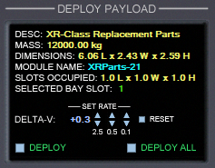

*Deploy Payload Screen in Orbit*

In addition, your selected payload’s thumbnail will be displayed on the *Target Payload* screen.

Before you click *DEPLOY* to deploy your selected payload you should first set your desired *delta-V* for it: this is the velocity at which the payload module will be “pushed away from the ship.” The default value is 0.2 meter-per-second, which should be fine in most cases. As with other XR-class touch screens, in addition to clicking the delta-V arrows you can also *hold down your mouse button* on the arrows to change the values quickly. Click *Reset* to reset the delta-V to zero.

Once you have set your desired delta-V, press *DEPLOY* to deploy your selected payload module at the requested delta-V. (You may also use the ALT-U hotkey to deploy the selected module). As it is deployed you will see your ship’s mass decrease accordingly. If you want to deploy *everything in the bay simultaneously* using the same delta-V, use the *DEPLOY ALL* button or press the CTRL-ALT-U hotkey.

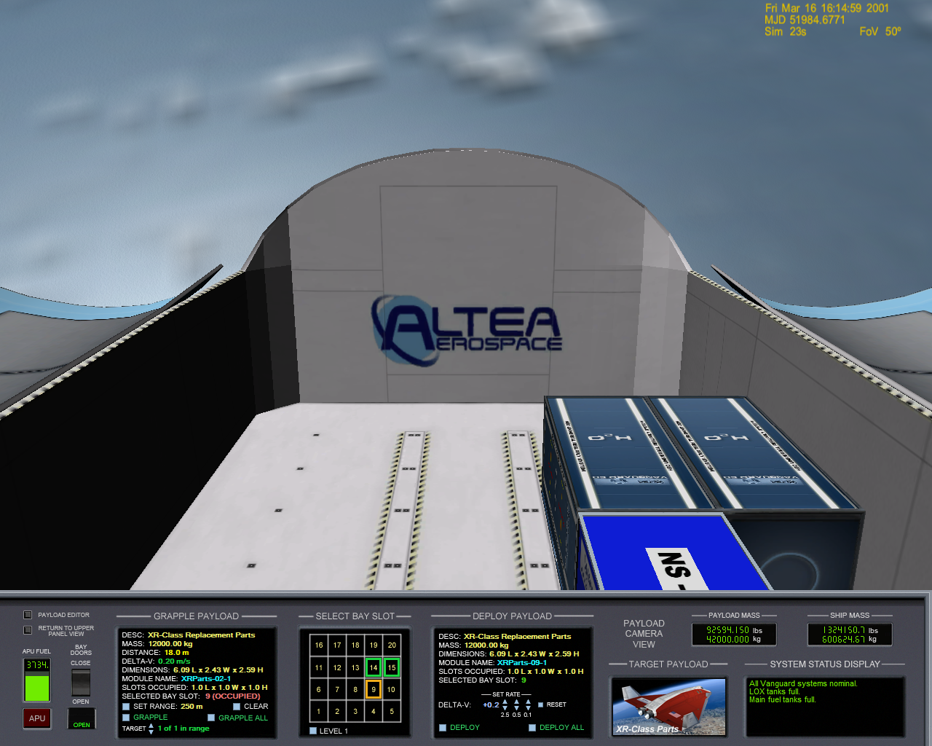

*XR5 Vanguard Payload Camera View with both Deploy and Grapple Targets Selected*

*Note: in the interests of playability, the ship allows you to deploy cargo from any slot even if there is cargo in a slot above it, “blocking” it. This was a design decision so that it would not be tedious to deploy a cargo first that you accidentally grappled into a level-one slot before you launched. You are still free, of course, to always deploy top-level cargo modules first so that lower-level modules will not be “blocked”, but in the interests of playability XR vessels do not enforce this.*

Deploying payload modules while landed is exactly the same as deploying in orbit *except* that there is no delta-V component: the payload in each slot is automatically deployed to a fixed location adjacent to the ship based on its slot location. The ship-relative coordinates to which the payload will be unloaded (i.e., “deployed”) are shown on the screen in place of the delta-V selection arrows.

Here is a screenshot showing a full payload bay deployed (i.e., unloaded) at Brighton Beach on the Moon:

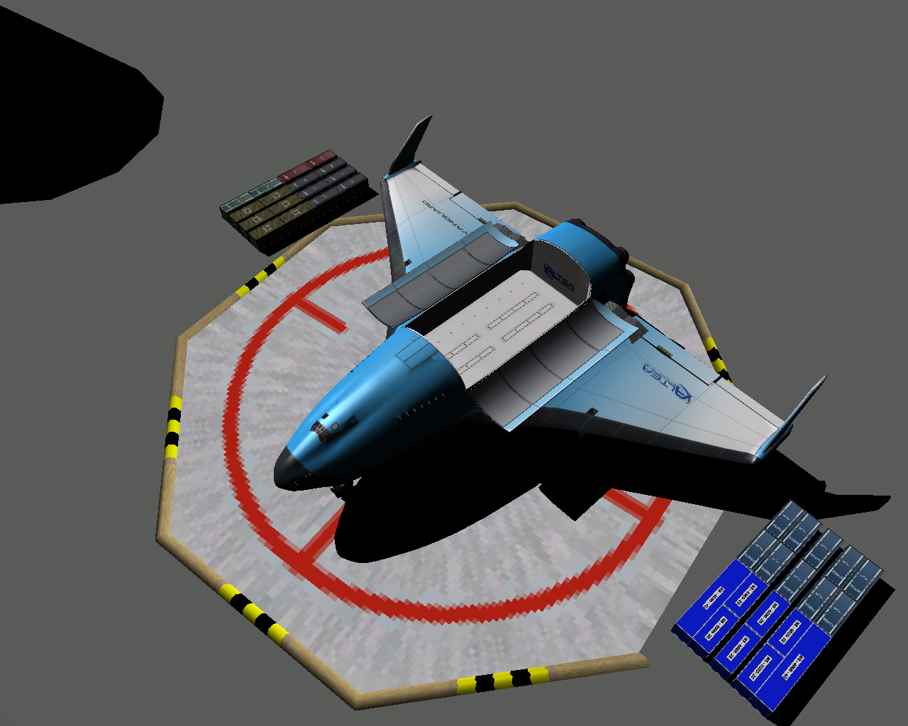

*XR5 Full Payload Bay Unloaded at Brighton Beach on the Moon*

***A Note Regarding Payload Mass***

*Your vessel’s total mass is continuously updated each frame by scanning the total mass of each payload module/vessel attached in the payload bay and adding it to the normal vessel mass. This means, for example, that if you have any payload modules attached in the bay that are venting mass or burning consumables (like a bay fuel tank) you will see that reflected in real-time on the* Payload Mass *and* Ship Mass *displays. i.e., if any of your cargos’ masses change, it will be reflected in real-time by the XR vessel as well.*

## Using the Payload Editor

XR vessels make it easy to create/delete cargo modules via the Payload Editor dialog; this is useful for creating new scenarios where you want to start with cargo in the bay, or where you want to change the cargo that is in your bay at any time. Note that you do not need to use the payload editor in order to grapple or unload cargo: is only necessary if you want to *create new* payload modules in the bay or *delete existing* payload modules from the bay.

You may bring up the Payload Editor via Orbiter’s scenario editor (CTRL-F4 -> Scenario Editor -> Edit -> Payload Editor), the *Payload Editor* button on the payload panel, or you can use the ALT-B hotkey to toggle the Payload Editor dialog on/off. Note that your mouse cursor must be *off the dialog* in order for the ALT-B hotkey to *close* the window again: the reason is that the Orbiter core traps keystrokes sent to child dialogs, and so ALT-B can only work if the main Orbiter window has the focus. Alternatively, you can instead click the “<< Done” button to close the Payload Editor dialog.

Below is a screenshot of the Vanguard’s payload panel with the Payload Editor dialog displayed.

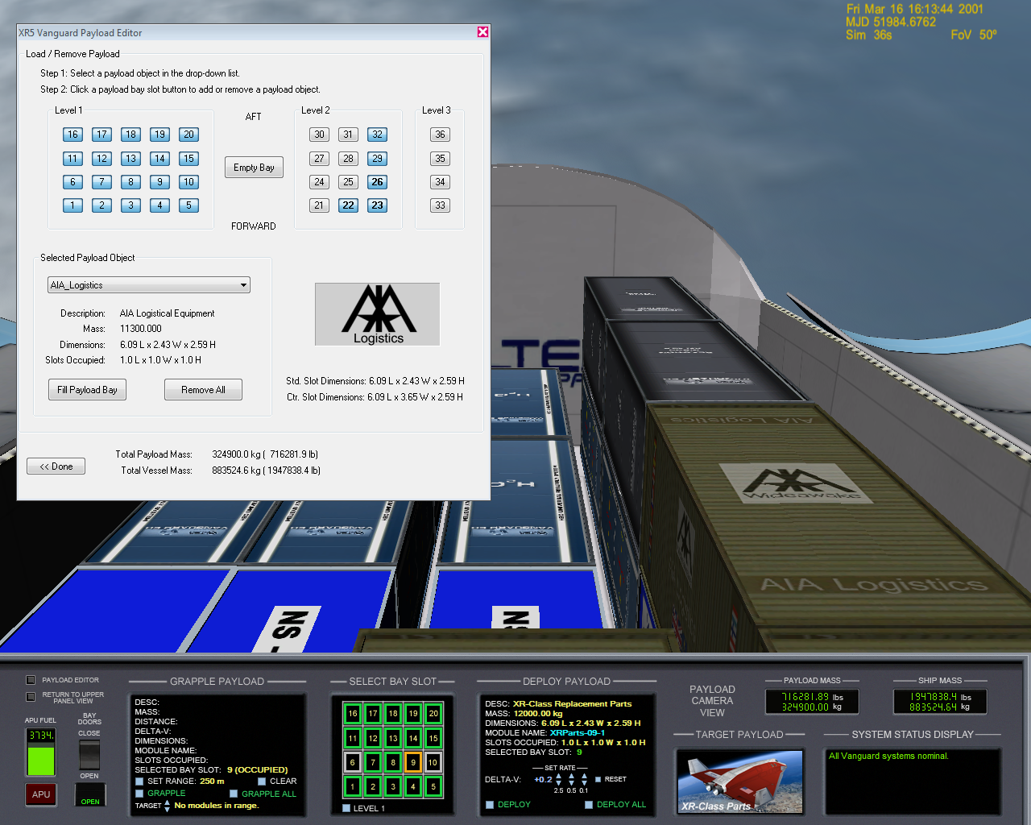

*XR5’s Payload Bay Camera and Instrument Panel View with the Payload Editor Displayed.*

When you bring up the editor, notice the *Selected Payload Object* drop-down list. This list contains all of the XR-payload-enabled cargo modules installed in Orbiter’s Config\Vessel directory. When you select a module type, its description, mass, dimensions, and number of slots occupied are displayed right below its type name, and a thumbnail bitmap is displayed in the right. Some XR cargo modules may not have a custom thumbnail defined, in which case a default *Altea Aerospace* thumbnail will be displayed.

Also, when you select a module type any existing modules of that type that are attached in the bay are highlighted in bold. Click on a slot number in the dialog to add or remove a module from that bay slot. If the module will not fit in the bay slot, an error beep will sound.

Notice in the screenshot above that some of the slot buttons are disabled: that indicates that the slot is occupied by a cargo module that is attached in an *adjacent* slot and the cargo module is too big to fit into a single slot. Note that the Vanguard’s centerline slots in the bay are slightly wider than the normal bay slots, so there may be certain payload modules that occupy *two* normal slots but only *one* centerline slot.

# Creating Your Own Payload Module

An XR-class payload-capable ship can carry *any vessel or module in Orbiter that can fit in its cargo bay*. All this is required to make an existing Orbiter vessel or cargo module compatible with all XR-class vessels are a few additional lines in the vessel’s configuration file. Note that most users will not need to read this section or deal with custom cargo modules: this section is intended for use by developers who want to create their own custom cargo modules ormodify existing cargo modules or vessels to be compatible with XR-class payload systems.

When Orbiter loads and the first XR ship instance is created, it scans the C:\Orbiter\Config\Vessels directory and parses all *.cfg files in it. Each .cfg file that is compatible with the XR Payload System is parsed and cached in a static, shared, vessel-wide cache for efficiency: scanning and parsing many configuration files is relatively expensive, and therefore the files are only scanned and parsed *once* for each XR vessel class. This means that if you install a new cargo module while Orbiter is running (which is unlikely anyway) you will need to bounce Orbiter before XR vessels can see it; in practical terms, however, this limitation is a non-issue.

The best way to create your own custom payload modules is to view an existing XR payload module’s data section, copy it to your *new* module’s .cfg file, and modify it as necessary. Below is a sample XR-payload-enabled vessel file named *XRParts.cfg;* this is installed with the Vanguard distribution to C:\Orbiter\Config\Vessels\XRParts.cfg. Other payload-enabled XR vessels include their own payload modules as well. Read the detailed comments in the payload .cfg file for instructions on how to create your own payload modules.

; === Configuration file for standard 20-ft XR Payload Cargo container ===

; Copyright 2007-2018 Douglas Beachy

; https://www.alteaaerospace.com

;************************************************************************************

; NOTE: the vessel's 'ClassName' *must match the name of the config file* so that

; the XR vessels can locate the .cfg file in Orbiter's config directory in order to

; parse the XR-payload-specfic data in it.

; For example, XRParts.cfg must contain 'ClassName=XRParts'.

;************************************************************************************

ClassName = XRParts

MeshName = XRPayload\XRParts

Size = 3.867

Mass = 12000 ; empty mass [kg] (max mass each for full load of 36 containers)

MaxFuel = 0 ; max fuel mass [kg]

Isp = 0 ; fuel specific impulse [m/s]

MaxMainThrust = 0

MaxRetroThrust = 0

MaxHoverThrust = 0

MaxAttitudeThrust = 0

CameraOffset = 0.0 .0 0.0

CW = 0.194 0.189 0.470

LiftFactor = 0.0

CrossSections = 7.060448 7.060448 14.769404

EnableFocus = true

TouchdownPoints = 0 -1.296 3.024 -1.217 -1.296 -3.024 1.217 -1.296 -3.024

;----------------------------------------------------

; XR Payload custom parameters

;----------------------------------------------------

; REQUIRED: must be set to 'true' for this vessel to be dockable in an XR-class payload bay.

XRPayloadEnabled = true

; cosmetic description; 127 chars MAX., but 40 chars or less recommended

Description = XR-Class Replacement Parts

; Dimensions in meters: X (width) Y (height) Z(length). This also determines how many standard payload slots are occupied.

Dimensions = 2.43 2.59 6.09

; (OPTIONAL) set to 'true' if this payload contains fuel or LOX that is consumable by the parent XR vessel

XRConsumableTank = false

; (OPTIONAL) Offset in meters from the center of the primary payload slot to the center of this payload's mass (X,Y,Z).

; If this is not set, the default is [0 0 0]. These coordinates are necessary so that the collision detection code can know the

; origin point (the "centerpoint") of the payload mass in order to determine how many slots this payload module will occupy.

; If you adjust your attachment point coordinates to center this module in its primary payload slot, these coordinates

; should be [0 0 0] (the default). If your payload is attached off-center in the slot along any axis, as will be the case

; if your payload occupies more than one slot, you will need to adjust these coordinates accordingly.

; For example, if your payload's center-of-mass is 0.3 meter below the centerpoint of its primary slot, this

; value should be 0 -0.3 0. As another example, if your payload is two slots long, one slot wide, and one slot high,

; this value should be set to 0 0 -3.048: the reason is that the center-of-mass of a 40-foot-long container is 3.048 meters

; (1/2 slot) AFT of the ceterpoint of the primary slot (the forward of the two slots it occupies).

PrimarySlotCenterOfMassOffset = 0 0 0

; (OPTIONAL) If this is not specified, a default thumbnail is used.

; Path relative to Orbiter config directory (e.g., "C:\Orbiter\Config") to the bitmap thumbnail image for this payload.

; This is displayed on the payload panel when this cargo is selected.

; This should point to a 24-bit-color bitmap that is 154x77 pixels in size.

; NOTE: do not use pure white (255,255,255) in your custom thumbnail bitmaps because that color is rendered

; as transparent when a bitmap is rendered on the panel.

ThumbnailPath = Vessels\XR1_Spare_Parts_Thumbnail.bmp

; (OPTIONAL): List of Orbiter vessel classnames for which an 'ExplicitAttachmentSlots' property is defined.

; VesselsWithExplicitAttachmentSlotsDefined = XR5Vanguard

; (OPTIONAL): These are optional parameters that only need to be defined for a given ship class if you have a

; large or specially-shaped payload. If no explicit attachment slots are defined, the ship will compute

; which slots are valid for this payload based on its dimensions and the location of its attachment point.

; If explicit attachment points *are* defined here they will override any calculations made by

; the ship as to whether this object will fit in the bay when attached to a given slot. However,

; they do *not* override checks as to whether this object will fit alongside *other payload* in the

; cargo bay. Most payload objects will not need to define this value.

;

; Format is: <parent vessel classname>_ExplicitAttachmentSlots = # # # ...

;XR5Vanguard_ExplicitAttachmentSlots = 3 8 13 18 22 25 28 31 33 34 35 36 ; center slots on all three levels only for testing

; (OPTIONAL) Defines a delta to be applied to this vessel when it is deployed on the ground. This is useful

; when the payload vessel defines touchdown points that are below the ground when the vessel is deployed.

; For example, '0.0 2.0 0.0' would deploy the vessel to 2.0 meters *higher* than normal when this payload

; is deployed while landed.

;GroundDeploymentAdjustment = 0 0 0

;----------------------------------------------------

; === Attachment specs ===

; NOTE: a payload object's attachment point should be set for the CENTER of the bay slot into which it is

; attached. Each standard slot is exactly 2.4384 wide (X), 2.5908 high (Y), 6.096 long (Z). Some XR-class

; ships, such as the XR5 Vanguard, have some slots that are wider as well.

; WARNING: attachment *direction* must be (0 1 0) and attachment *rotation* must be (0 0 1)! The bay

; collision detection code expects this.

; Note: only *one* BEGIN_ATTACHMENT/END_ATTACHMENT block may be present in any vessel's .cfg file.

; If you have multiple attachment points, you must declare them all in a single block.

; Also note that the XR attachment point *must* be labeled XRCARGO.

BEGIN_ATTACHMENT

P 0 0 0 0 1 0 0 0 1 XRCARGO

END_ATTACHMENT

## Publishing Your Payload Module

After you have created your new payload module and tested it, please consider publishing it to make it available for other XR pilots as well. If want to host your new payload module on your own Web site, I would be happy to link to your page from the *Payload* section on my Web page at [https://www.alteaaerospace.com](https://www.dougsorbiterpage.com/). If you prefer, I would also be happy to host your new payload module on my Web page, crediting you as the author. If you would like me to link to your page or host your payload on my page, please drop me an email at [doug.beachy@outlook.com](mailto:doug.beachy@outlook.com).

# XR2-01_Bay/XR5-01_Bay Vessel Saved in Scenario Files

A note regarding the XR2-01_Bay/XR5-01_Bay vessels you will see in saved Ravenstar and Vanguard scenarios: this is an invisible phantom vessel attached behind the XR vessel’s payload bay to force the Orbiter core to render the payload bay even when no cargo is present. If you delete the vessel from the scenario file no harm is done: the XR vessel will recreate it automatically when the scenario loads. Do not delete the phantom vessel in-game, however, or the cargo bay will no longer be rendered in the payload camera view unless there is at least one payload module in close proximity to the bay. This is an Orbiter core limitation.

# Installing and Using a Custom Skin

XR vessels support any number of custom skins so long as each skin installed to its own subdirectory under %*ORBITER_ROOT%*\Textures\{SHIPNAME}>\Skins. If the custom skin was created with an XR Skin Pack, you should be able to install the skin simply by unzipping the skin’s zip file into your Orbiter root directory; refer to the readme.txt file in the skin’s zip file for details.

If you want to create a new custom skin for your favorite vessel you should download corresponding XR vessel’s paint kit available on my Orbiter page ([https://www.alteaaerospace.com](https://www.dougsorbiterpage.com/)). It contains detailed instructions on how to create, test, and release your new skin; it also contains the default vessel exterior textures in PSD and BMP format that you can use as a starting point.

More information is available in the paint kits, but for example, to install your own Vanguard custom skin, deploy your custom texture files to a new C:\Orbiter\Textures\XR5Vanguard\Skins\Foobar directory. Once the files are installed, set the skin directory name in the scenario file as follows:

SKIN **Foo**

…where **Foo** is the directory name under C:\Orbiter\Textures\XR5Vanguard\Skins; e.g., C:\Orbiter\Textures\XR5Vanguard\Skins\Foobar\. Each Vanguard ship defined in the scenario may use a different or the same skin. If the *SKIN* property is not set, the default skin is used.

# Submitting a Feature Request or Bug Report

Before submitting a bug report, please check my Web page for updates and other information at [https://www.alteaaerospace.com](https://www.dougsorbiterpage.com/) It is possible that a newer version of the ship is available, and I can only work on bugs that are present in the latest ship version.

If you have a question about an XR vessel, please post your request to the Orbiter *Addon Support and Bugs* forum here:

<https://orbiter-forum.com/forumdisplay.php?f=51>

*NOTE: if you are defining any [CHEATCODE] values in your vessel’s config file it is quite possible that one of your CHEATCODE values is causing the problem; please re-test the problem after commenting out all [CHEATCODE] values.*

If the bug is a simple typo in the documentation or something trivial like that, please email me directly at [doug.beachy@outlook.com](mailto:doug.beachy@outlook.com).

For non-trivial bugs, please write up a bug report as specified below and post it to the Orbiter forum’s *Addon Support and Bugs* sectionhere:

<https://orbiter-forum.com/forumdisplay.php?f=51>

**Please include the following information in your bug report:**

1. The XR vessel name and version you are using; this can be found in your C:\Orbiter\SHIPNAME.log (e.g., XR5Vanguard.log) file.
2. The Orbiter version you are using.
3. Whether the bug occurs in a clean Orbiter installation (i.e., with only *Orbiter*, *XRSound*, and the *XR vessel* installed). Your bug is more likely to be fixed (or at least fixed *sooner*) if the problem occurs in a clean Orbiter installation.
4. The exact steps to reproduce the bug. If the bug is not reproducible, please be as specific as possible about what you were doing when the bug occurred. Note that if a bug is reproducible it is more likely to be fixed.
5. The complete contents of a scenario file to reproduce the bug. Remember to enclose your scenario file text in **[code]** and **[/code]** tags when constructing your post on the Orbiter forum.

You may reach me on the [Orbiter forum](http://orbiter-forum.com/) as [dbeachy1](http://www.orbiter-forum.com/member.php?u=104).

# Appendix A: Notes

* For non-full-screen display modes in Orbiter, XR vessels automatically save Orbiter’s display window coordinates on exit and restore (move) the window to its saved coordinates on startup. To disable this behavior, set the following registry key:

HKEY_LOCAL_MACHINE\SOFTWARE\AlteaAerospace\XR\Disable -> DWORD:DisableWindowPosRestore = 1

There is a separate set of saved coordinates for each given window size.

* *Altea* in *Altea Aerospace* is pronounced ***all-TEE-uh*** or ***al-TAY-uh*** (both pronunciations are correct).
* For a more realistic challenge, edit your ship’s config file and make the following change:
  + **MainFuelISP=1** (sets main fuel burn rate to REALISTIC – suitable for ISS or LEO only)

* If you are an expert pilot and looking for a real challenge, make the following changes:
  + **MainFuelISP=0** (sets main fuel burn rate to EXPERT – ISS Only w/expert use of SCRAM engines and expert deorbit/landing)
  + **APUFuelBurnRate=5** (sets APU fuel burn rate to EXPERT)

Now take off using the default *Ready for takeoff to ISS* scenario, dock with the ISS, and deorbit to KSC. If you fly it perfectly you should be able to land back at KSC without refueling. Good luck!

* You may alter or even delete any of an XR vessel’s custom speech callouts and sound effects by editing or deleting the wav files in your $ORBITER_ROOT\XRSound\Default directory: if a callout or sound effect is missing, it is simply not played – it is not an error. This allows pilots to change or remove any callouts or sound effects they don’t like. Note that you may also enable/disable different types of callouts by editing your ship’s configuration file.

# Appendix B: Technical Data

*Note: engine thrust data assumes the vessel is configured for* Realistic *(the default) settings in the configuration file.*

**XR Technical Specifications**

|  |  |  |  |
| --- | --- | --- | --- |
| **Description** | **DG-XR1** | **XR2 Ravenstar** | **XR5**  **Vanguard** |
| Max positive wing load | 17000 N/m^2 | 17000 N/m^2 | 17000 N/m^2 |
| Max negative wing load | 11000 N/m^2 | 11000 N/m^2 | 11000 N/m^2 |
| Max dynamic pressure (absolute) | 150 kPa | 150 kPa | 150 kPa |
| Landing Gear Energy Absorption Limit | 8.04e+4 kg m/s2 | 1.29e+5 kg m/s2 | 2.57e+6 kg m/s2 |
| Max touchdown descent rate, max load (full fuel, full cargo) | 3.1 m/s | 2.8 m/s | 2.6 m/s |
| Max touchdown descent rate, typical load (33% fuel, 75% cargo) | 5.8 m/s | 4.2 m/s | 3.5 m/s |
| Crew Survivability Limit (max vertical impact velocity) | 39 m/s | 39 m/s | 39 m/s |
| Max bank at touchdown | 15 degrees | 15 degrees | 15 degrees |
| Max pitch at touchdown | 16 degrees | 16 degrees | 16 degrees |
| Max dynamic pressure: Crew Elevator deployed | N/A | N/A | 9 kPa |
| Max dynamic pressure: Radiator Deployed | 16 kPa | 16 kPa | 16 kPa |
| Max dynamic pressure: Cabin Hatch deployed | 20 kPa | 20 kPa | 20 kPa |
| Max dynamic pressure: Docking Port/Nosecone open | 32 kPa | 32 kPa | 32 kPa |
| Max dynamic pressure: Payload Doors open | N/A | 36 kPa | 36 kPa |
| Max dynamic pressure: Landing Gear deployed | 39 kPa | 39 kPa | 39 kPa |
| Max dynamic pressure: Retro Doors deployed | 41 kPa | 41 kPa | 41 kPa |
| Hull Thermal Failure at temperature limit (single surface) | ~8 seconds (typical) | ~8 seconds (typical) | ~8 seconds (typical) |
| Max surface heating: NOSECONE | 2840 C  (5144 F) | 2840 C  (5144 F) | 2840 C  (5144 F) |
| Max surface heating: WINGS | 2380 C  (4316 F) | 2380 C  (4316 F) | 2380 C  (4316 F) |
| Max surface heating: COCKPIT | 1490 C  (2714 F) | 1490 C  (2714 F) | 1490 C  (2714 F) |
| Max surface heating: TOP HULL | 1210 C  (2210 F) | 1210 C  (2210 F) | 1210 C  (2210 F) |
| Empty Mass | 12,000 kg | 16,080 kg | 266,400 kg |
| Main Fuel Mass | 10,400 kg | 13,396 kg | 230,880 kg |
| RCS Fuel Mass | 600 kg | 804 kg | 13,320 kg |
| SCRAM Fuel Mass | 2,500 kg | 3,350 kg | 55,500 kg |
| APU Fuel Mass | 200 kg | 268 kg | 4,440 kg |
| LOX Mass [5] *(see footnote)* | 65 kg (7 days) to 3389 kg (5 years) | 182 kg (7 days) to 47,438 kg (5 years) | 234 kg (7 days) to 60,991 kg (5 years) |
| Fully Loaded Mass w/14-day LOX and full crew complement (no cargo) | 26,254 kg | 35,748 kg | 572,225 kg |
| Length | 17.76 meters | 23.91 meters | 60.34 meters |
| Wingspan | 17.86 meters | 18.95 meters | 76.67 meters |
| Rear Gear Track | 6.82 meters | 7.48 meters | 35.61 meters |
| Payload Bay Capacity | N/A | 3 custom payload slots (approx. 30 cubic meters) | 36 Standard Cargo slots (approx. 2,500 cubic meters) |
| Maximum Payload Mass | N/A | 10,795 kg (max recommended) | 432,000 kg (max recommended) |
| Main Engine Thrust in Vacuum | 192 kN x 2  384 kN total | 302 kN x 2  605 kN total | 1,420 kN x 6  8,524 kN total |
| Hover Engine Thrust in Vacuum | 88 kN x 3  264 kN total | 208 kN x 2  415 kN total | 977 kN x 6  5,860 kN total |
| Maximum SCRAM Engine Thrust | ~160 kN x 2  ~320 kN total | ~350 kN x 2  ~700 kN total | ~5,250 kN x 2  ~10,500 kN total |
| Retro Engine Thrust in Vacuum | 40.8 kN x 2  81.6 kN total | 64.2 kN x 2  129 kN total | 905 kN x 2  1,811 kN total |
| SCRAM Diffuser Thermal Limit | 8000° Kelvin | 8000° Kelvin | 8000° Kelvin |
| APU Runtime (“low” *APUFuelBurnRate* default setting) | ~110 minutes | ~110 minutes | ~110 minutes |
| APU Startup/Shutdown time | 2.5 seconds (nominal) | 2.5 seconds (nominal) | 2.5 seconds (nominal) |
| Principal Moments of Inertia (PMI) | 15.5 / 22.1 / 7.77 | 32.04 / 42.56 / 13.17 | 317.35 / 305.08 / 219.45 |
| Cross Sections | 55.13 / 190.53 / 26.41 | 77.46 / 238.98 / 30.14 | 543.82 / 1962.75 / 330.97 |
| Center of Mass (in meters) | 0.0, -0.07,  -0.50 | 0.0, 0.41,  -2.05 | 0.0, 10.45,  -4.66 |
| Crew Complement | 5 | 14 | 18 |
| Gear deployment time | 6.7 seconds | 6.7 seconds | 6.7 seconds |
| Docking Port / Nosecone deployment time | 20.0 seconds | 20.0 seconds | 20.0 seconds |
| Crew Elevator deployment time | N/A | N/A | 35.0 seconds |
| Airlock doors opening time | 10.0 seconds | 10.0 seconds | 10.0 seconds |
| Airlock chamber pressurization time | 28.0 seconds (vacuum to 14.7 psi) | 28.0 seconds (vacuum to 14.7 psi) | 28.0 seconds (vacuum to 14.7 psi) |
| Radiator deployment time | 32.0 seconds | 32.0 seconds | 32.0 seconds |
| Airbrake deployment time | 3.3 seconds | 3.3 seconds | 3.3 seconds |
| Payload Bay Doors opening time | N/A | 22.0 seconds | 35.0 seconds |
| Crew Hatch opening time | 6.6 seconds | 6.6 seconds | 6.6 seconds |
| Retro Doors opening time | 3.3 seconds | 3.3 seconds | 3.3 seconds |
| Hover Doors opening time | 5.0 seconds | 5.0 seconds | 5.0 seconds |
| SCRAM Doors opening time | 3.0 seconds | 3.0 seconds | 3.0 seconds |
| Main Refueling Line Pressure | 22.2 psi nominal, 30 psi max | 22.2 psi nominal, 30 psi max | 22.2 psi nominal, 30 psi max |
| SCRAM Refueling Line Pressure | 15.6 psi nominal, 21 psi max | 15.6 psi nominal, 21 psi max | 15.6 psi nominal, 21 psi max |
| APU Refueling Line Pressure | 4.5 psi nominal, 6 psi max | 4.5 psi nominal, 6 psi max | 4.5 psi nominal, 6 psi max |
| LOX Resupply Line Pressure | 11.1 psi nominal, 15.0 psi max | 11.1 psi nominal, 15.0 psi max | 11.1 psi nominal, 15.0 psi max |
| Resupply Line Pressurization Time­­ | 5.0 seconds (nominal) | 5.0 seconds (nominal) | 5.0 seconds (nominal) |
| Internal Coolant Temperature | 32.2 C nominal, 89 C max | 32.2 C nominal, 89 C max | 32.2 C nominal, 89 C max |
| Transponder (XPDR) Frequency | 117.65 MHz | 118.05 MHz | 117.75 MHz |
| Docking Port (IDS) Frequency | 117.95 MHz | 118.15 MHz | 117.85 MHz |
| Gear Compression | N/A | N/A | 0.95 meter |
| Wheelbrake Force | 100 kN | 134 kN | 2,220 kN |

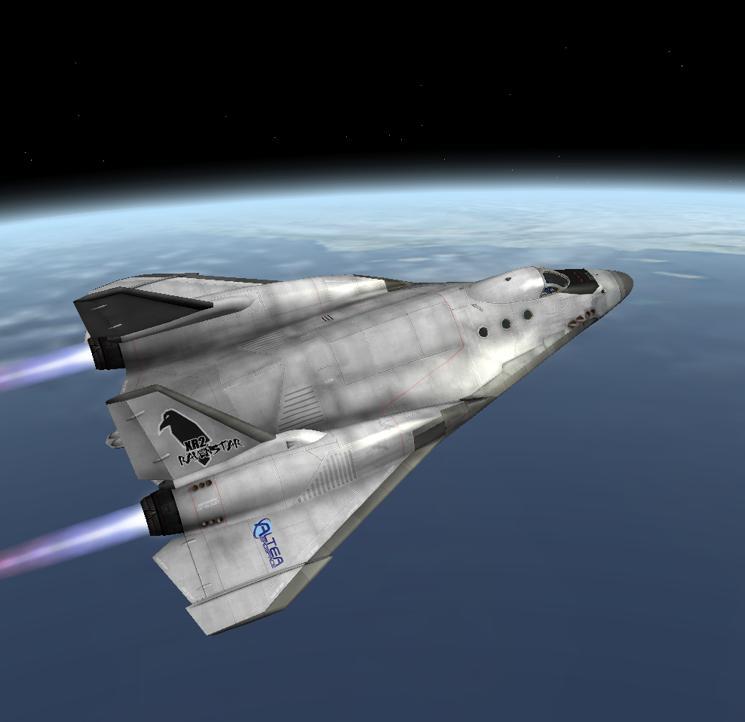

*XR2 Ravenstar Leaving Earth Orbit*

*-- end --*

1. Remember that SCRAM engine heat damage may be disabled in the XR5VanguardPrefs.cfg file if desired; in that case the gauge will continue to display the diffuser temperature, but exceeding the limits will not damage the ship.
2. You may disable this realism feature by setting EnableATMThrustReduction=0 in your XR5VanguardPrefs.cfg file.
3. The maximum grapple distance while in orbit may be altered by setting the PayloadGrappleRangeOrbit CHEATCODE setting in your vessel’s configuration file (e.g., XR5VanguardPrefs.cfg).
4. The maximum grapple distance while landed may be altered by setting the PayloadGrappleRangeLanded CHEATCODE setting in your vessel’s configuration file (e.g., XR5VanguardPrefs.cfg).
5. The maximum LOX listed here assumes that *LOXConsumptionRate* in the config file is set to its default of **AUTO**; the amount of LOX loaded will be higher if *LOXConsumptionRate* is changed. For example, if *LOXConsumptionRate* is set to *Realistic*, the actual LOX loaded for a five-year mission would be 16,942 kg (37,350 pounds).